Section 5: Upper Extremity

Card ID: 5.1
Image file: L1344_760114
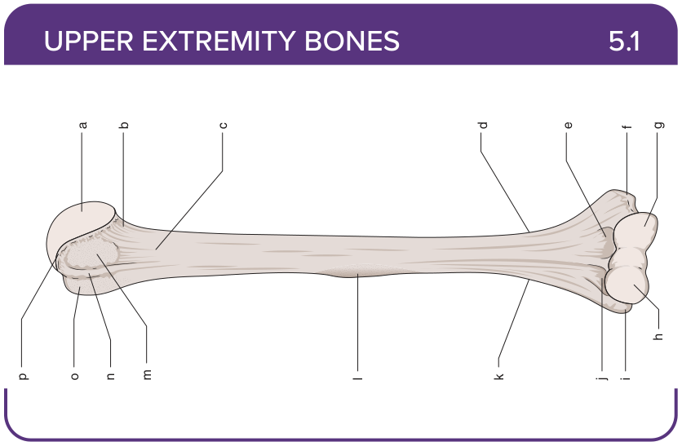
Title: Humerus (Anterior)
Activity Interaction: Drag and drop
Back-of-Card Content:
a. Head
b. Anatomical neck
c. Surgical neck
d. Medial supracondylar ridge
e. Coronoid fossa
f. Medial epicondyle
g. Trochlea
h. Capitulum
i. Lateral epicondyle
j. Radial fossa
k. Lateral supracondylar ridge
l. Deltoid tuberosity
m. Lesser tuberosity
n. Bicipital groove
o. Great tuberosity
p. Superior aspect of the anatomical neck

Card ID: 5.2
Image file: L1344_760115
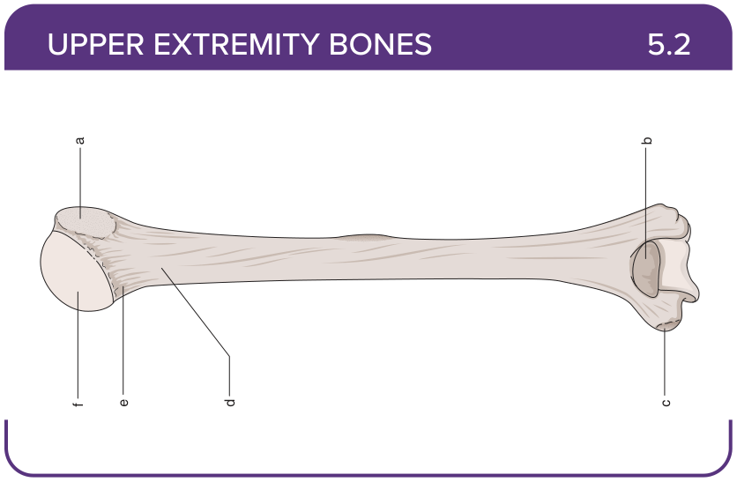
Title: Humerus (Posterior)
Activity Interaction: Drag and drop
Back-of-Card Content:
a. Greater tuberosity
b. Olecranon fossa
c. Medial epicondyle
d. Surgical neck
e. Anatomical neck
f. Head

Card ID: 5.3
Image file: L1344_762040
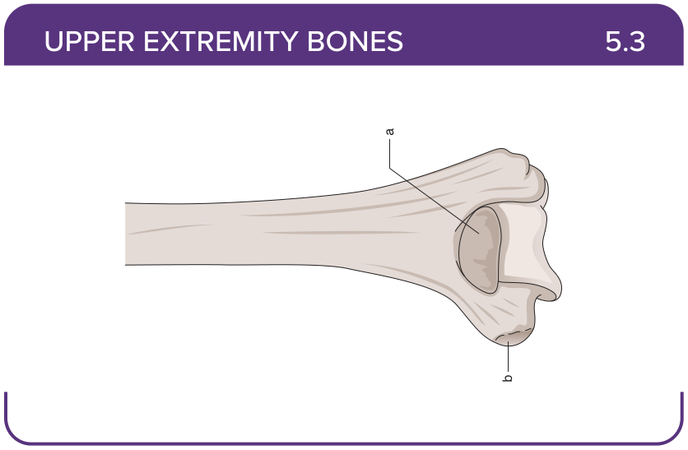
Title: Distal Humerus (Posterior)
Activity Interaction: Drag and drop
Back-of-Card Content:
a. Olecranon fossa
b. Medial epicondyle

Card ID: 5.4
Image file: L1344_760116
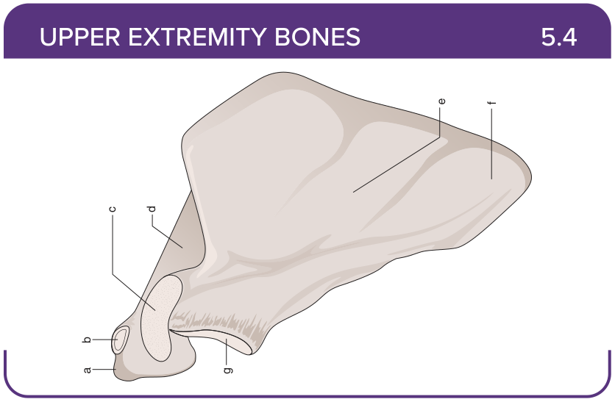
Title: Scapula (Anterior)
Activity Interaction: Drag and drop
Back-of-Card Content:
a. Acromion process
b. Facet for clavicle
c. Coracoid process
d. Spine
e. Subscapular fossa
f. Inferior angle
g. Glenoid fossa

Card ID: 5.5
Image file: L1344_760117
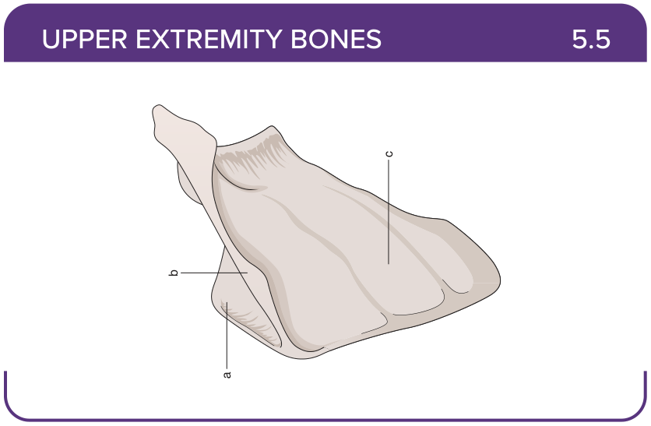
Title: Scapula (Posterior)
Activity Interaction: Drag and drop
Back-of-Card Content:
a. Supraspinous fossa
b. Spine
c. Infraspinous fossa

Card ID: 5.6
Image file: L1344_760118
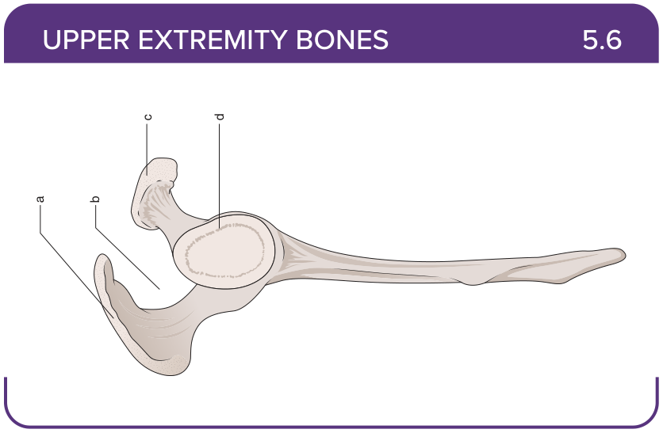
Title: Scapula (Lateral)
Activity Interaction: Drag and drop
Back-of-Card Content:
a. Acromion process
b. Supraspinous fossa
c. Coracoid process
d. Glenoid fossa

Card ID: 5.7
Image file: L1344_760119
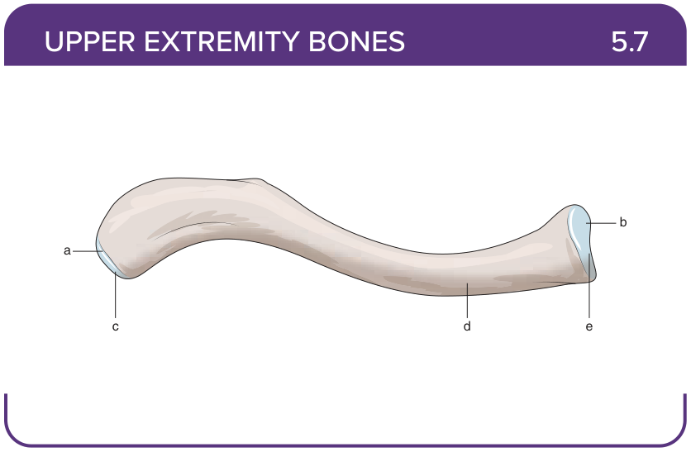
Title: Clavicle (Superior)
Activity Interaction: Drag and drop
Back-of-Card Content:
a. Acromial (lateral) end
b. Sternal (medial) end
c. Acromial facet
d. Shaft
e. Sternal facet

Card ID: 5.8
Image file: L1344_760120
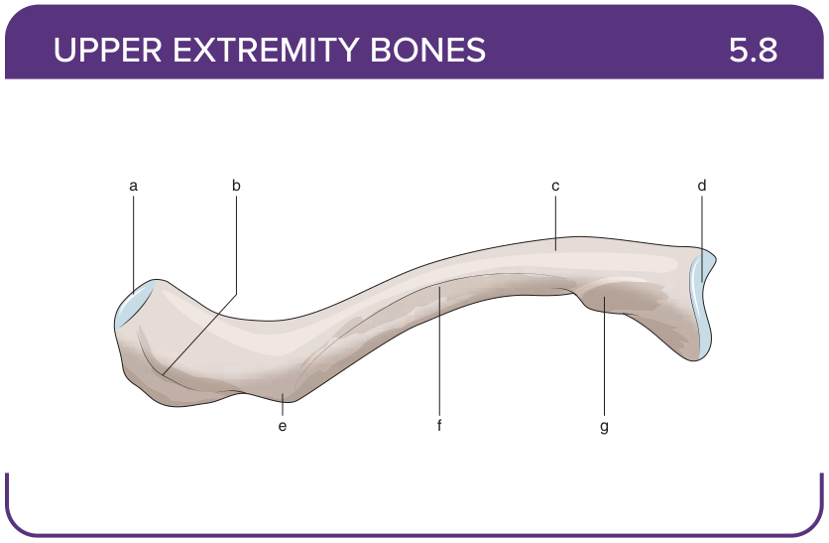
Title: Clavicle (Inferior)
Activity Interaction: Drag and drop
Back-of-Card Content:
a. Acromial (lateral) end
b. Trapezoid line
c. Shaft
d. Sternal (medial) end
e. Conoid tubercle
f. Subclavian groove
g. Costal tuberosity

Card ID: 5.9
Image file: L1344_760121
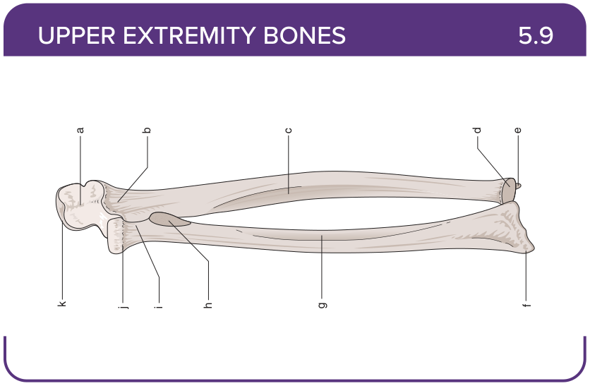
Title: Radius and Ulna (Anterior)
Activity Interaction: Drag and drop
Back-of-Card Content:
a. Trochlear notch
b. Coronoid process
c. Interosseous border of the ulna
d. Head of the ulna
e. Styloid process of the ulna
f. Styloid process of the radius
g. Interosseous border of the radius
h. Radial tuberosity
i. Neck of the radius
j. Head of the radius
k. Olecranon

Card ID: 5.10
Image file: L1344_760122
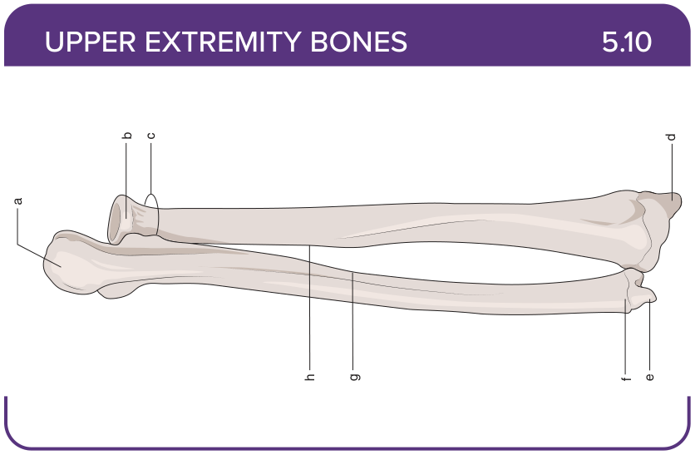
Title: Radius and Ulna (Posterior)
Activity Interaction: Drag and drop
Back-of-Card Content:
a. Olecranon
b. Head of the radius
c. Neck of the radius
d. Styloid process of radius
e. Styloid process of the ulna
f. Head of the ulna
g. Interosseous border of the ulna
h. Interosseous border of the radius

Card ID: 5.11
Image file: L1344_760123
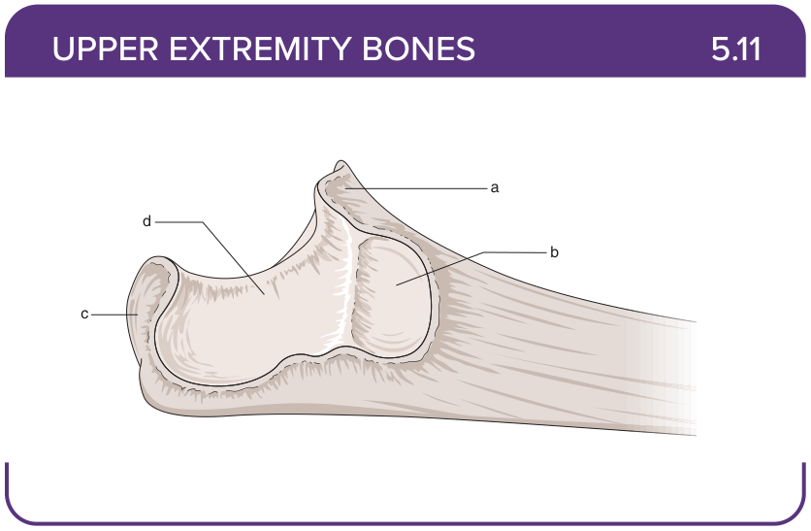
Title: Proximal End of the Ulna
Activity Interaction: Drag and drop
Back-of-Card Content:
a. Coronoid process
b. Radial notch
c. Olecranon
d. Trochlear notch

Card ID: 5.12
Image file: L1344_760124
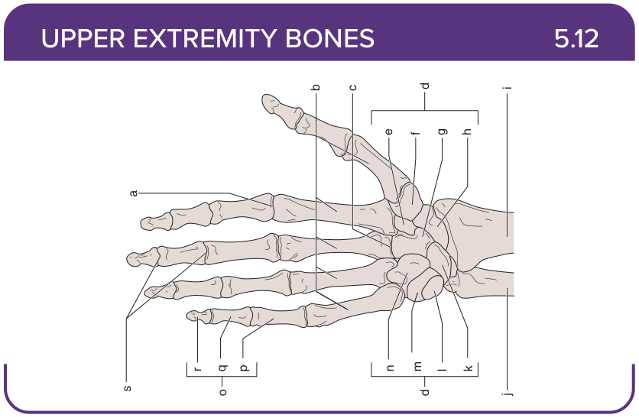
Title: Wrist and Hand (Volar)
Activity Interaction: Drag and drop
Back-of-Card Content:
a. Metacarpophalangeal joint
b. Metacarpals (5)
c. Carpometacarpal (CMC) joint
d. Carpals
e. Trapezoid
f. Trapezium
g. Capitate
h. Scaphoid (navicular)
i. Radius
j. Ulna
k. Lunate
l. Pisiform
m. Triquetrum
n. Hamate
o. Phalanges
p. Proximal phalange
q. Middle phalange
r. Distal phalange
s. Interphalangeal joints

Card ID: 5.13
Image file: L1344_760125
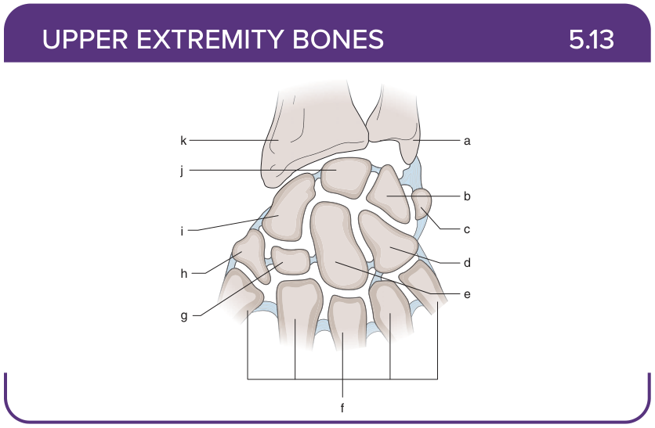
Title: Metacarpals (Dorsal)
Activity Interaction: Drag and drop
Back-of-Card Content:
a. Ulna
b. Triquetrum
c. Pisiform
d. Hamate
e. Capitate
f. Metacarpals
g. Trapezoid
h. Trapezium
i. Scaphoid
j. Lunate
k. Radius

Card ID: 5.14
Image file: L1344_760126
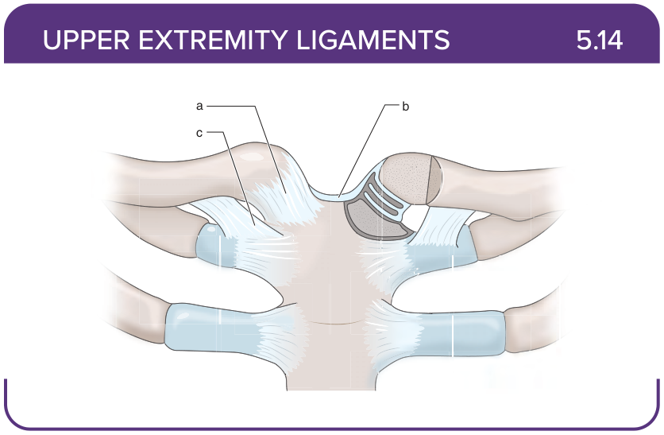
Title: Sternoclavicular Joint
Activity Interaction: fill-in-the-blank
Back-of-Card Content:
a. Anterior sternoclavicular ligament: restricts anterior displacement of the clavicle
b. Interclavicular ligament: stabilizes sternoclavicular joint
c. Costoclavicular ligament: stabilizes sternoclavicular joint

Card ID: 5.15
Image file: L1344_760127
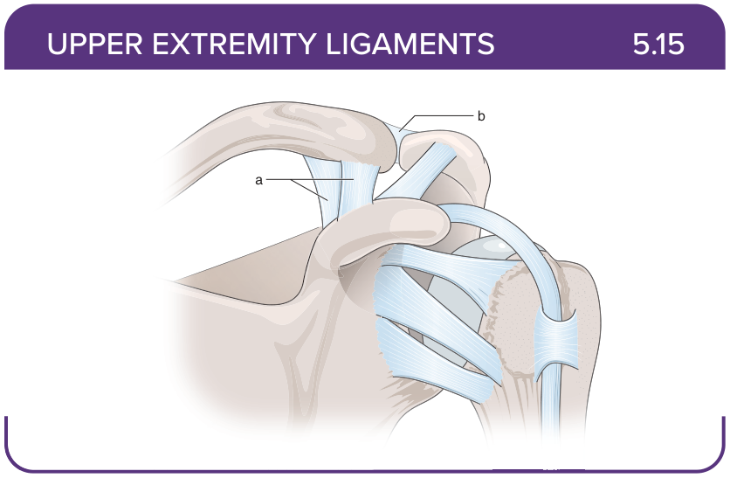
Title: Acromioclavicular Joint
Activity Interaction: fill-in-the-blank
Back-of-Card Content:
a. Coracoclavicular ligament (conoid and trapezoid ligaments): restricts superior dislocation of the acromioclavicular (AC) joint, rotation of the scapula
b. Acromioclavicular ligament: restricts anterior-posterior translation and posterior axial rotation, reinforces joint capsule

Card ID: 5.16
Image file: L1344_760128
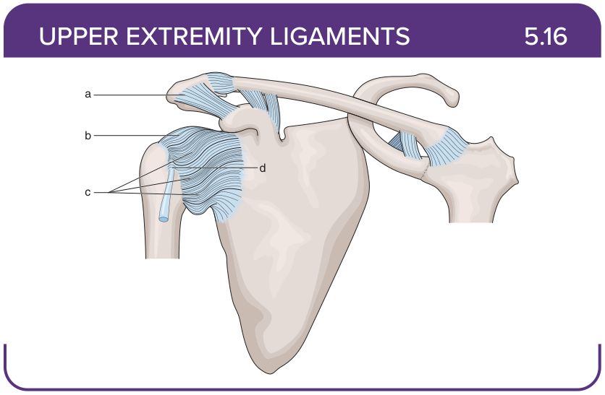
Title: Glenohumeral Ligaments
Back-of-Card Content:
Activity Interaction: fill-in-the-blank
a. Coracoacromial ligament: restricts superior displacement of the humeral head
b. Coracohumeral ligament: restricts excessive external rotation and inferior translation of the humerus
c. Glenohumeral ligaments (superior, middle, inferior): Restricts − Superior: external rotation and inferior translation of the humeral head − Middle: external rotation and anterior translation of the humeral head − Inferior (anterior): external rotation and superior and anterior translation of the humeral head − Inferior (posterior): internal rotation and anterior translation
d. Transverse humeral ligament: restricts the exit of the long head of the biceps from the bicipital groove

Card ID: 5.17
Image file: L1344_760129
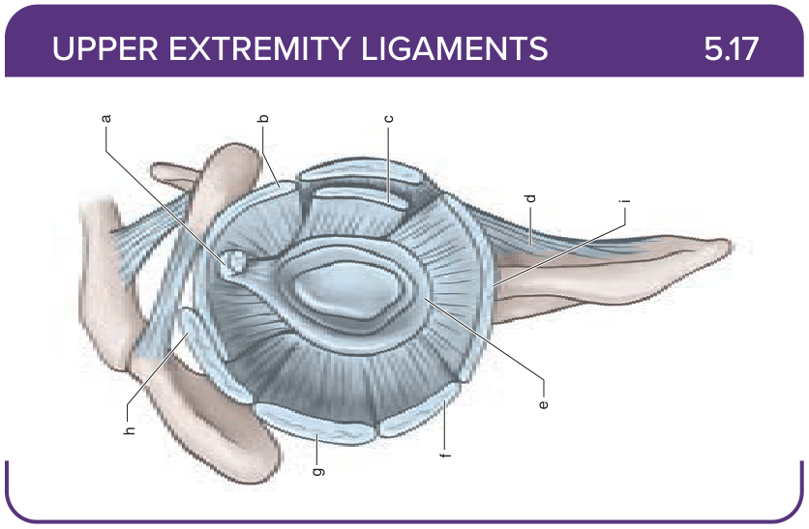
Title: Glenohumeral Ligaments (Lateral)
Activity Interaction: drag and drop
Back-of-Card Content:
a. Long head of the biceps
b. Superior glenohumeral ligament
c. Middle glenohumeral ligament
d. Subscapularis tendon
e. Inferior glenohumeral ligament complex
f. Labrum
g. Teres minor tendon
h. Infraspinatus tendon
i. Supraspinatus tendon

Card ID: 5.18
Image file: L1344_760130
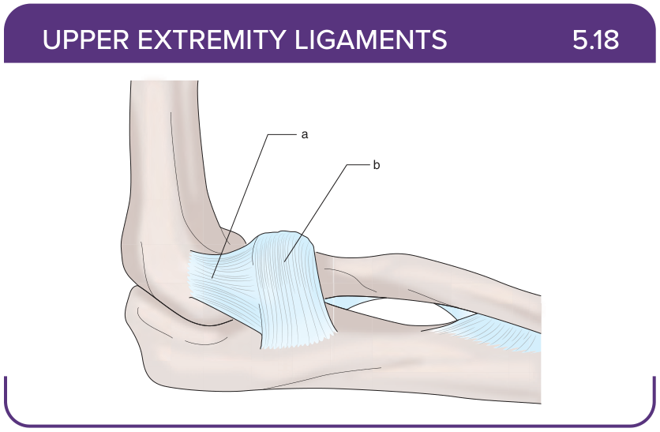
Title: Radioulnar Joint (Lateral)
Activity Interaction: fill-in-the-blank
Back-of-Card Content:
a. Radial collateral ligament (lateral collateral ligament): restricts excess varus stress
b. Annular ligament of the radius: stabilizes radial head to the ulna in the radial notch

Card ID: 5.19
Image file: L1344_760131
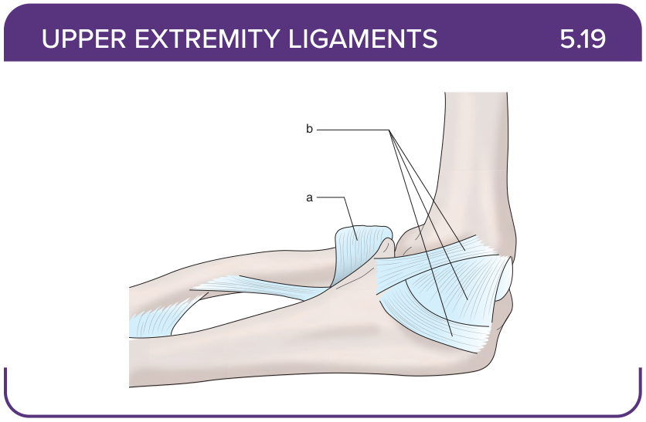
Title: Radioulnar Joint (Medial)
Activity Interaction: fill-in-the-blank
Back-of-Card Content:
a. Annular ligament of the radius: stabilizes radial head to the ulna in the radial notch
b. Ulnar collateral ligament (medial collateral ligament): restricts excess valgus stress

Card ID: 5.20
Image file: L1344_760132
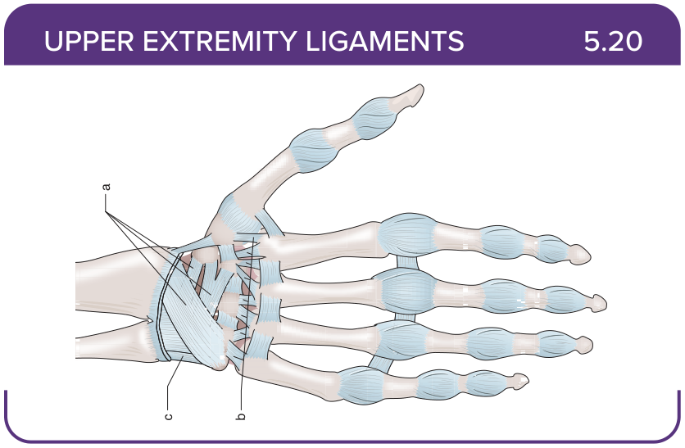
Title: Radiocarpal and Intercarpal Ligaments
Activity Interaction: fill-in-the-blank
Back-of-Card Content:
a. Dorsal radiocarpal ligament: restricts wrist flexion
b. Palmar and dorsal carpometacarpal ligaments: stabilize CMC joints
c. Palmar ulnocarpal ligament: stabilizes ulnocarpal joint, prevents displacement of the head of the ulna

Card ID: 5.21
Image file: L1344_760133
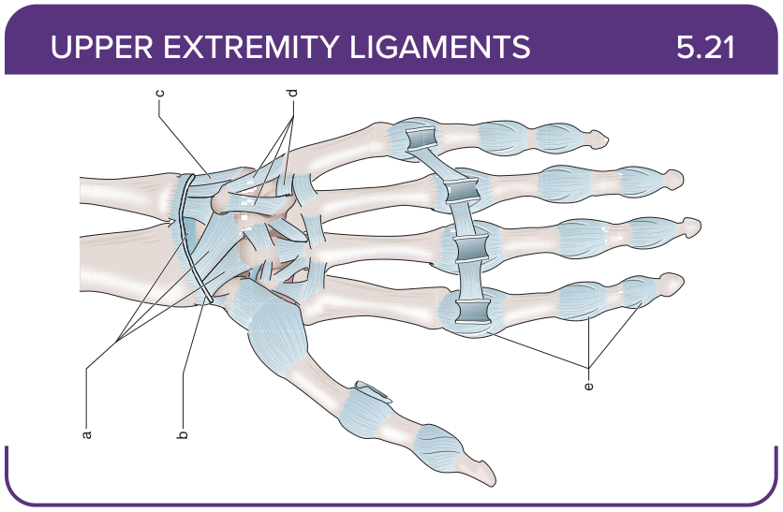
Title: Radiocarpal and Intercarpal Ligaments
Activity Interaction: fill-in-the-blank
Back-of-Card Content:
a. Volar (palmar) radiocarpal ligament: restricts wrist extension
b. Radial collateral ligament: restricts adduction of the wrist/ulnar deviation
c. Ulnar collateral ligament of the wrist: restricts wrist abduction/radial deviation
d. Intercarpal ligaments (dorsal, palmar, interosseous): restricts separation of the carpal bones
e. Collateral ligaments of the metacarpophalangeal (MCP) and interphalangeal (IP) joints: restricts sideways movement of the joint

Card ID: 5.22
Image file: L1344_762048
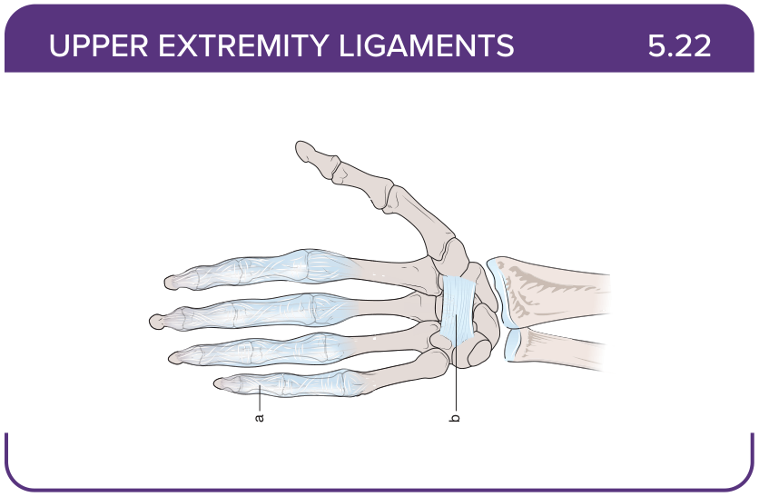
Title: Upper extremity: Palmar ligaments
Activity Interaction: fill-in-the-blank
Back-of-Card Content:
a. Palmar ligaments (volar plates): restricts hyperextension
b. Transverse carpal ligament (flexor retinaculum): the roof of the carpal tunnel

Card ID: 5.23
Image file: L1344_760134
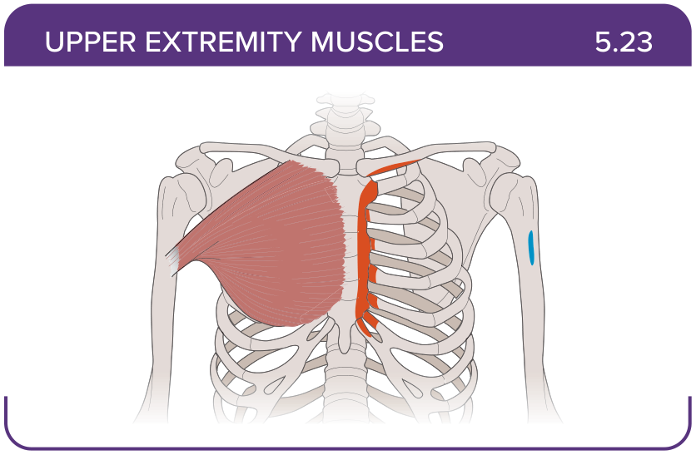
Title: Pectoralis major
Activity Interaction: select all that apply
Back-of-Card Content:
Proximal insertion:
- *anterior surface of the medial half of the clavicle
- sternum and costal cartilages of ribs 1-6
- anterior ends of ribs three to five
- superior surface of the costal end of the first rib

Distal insertion:
- lateral lip of the bicipital groove of the humerus
- lateral lip of the bicipital groove of the humerus
- coracoid process of the scapula
- medial surface of the humeral shaft

Innervation:
  - lateral pectoral nerve
  - medial pectoral nerve
- subclavian (C5-C6) nerve
- musculocutaneous nerve
Action:
- *adduction at the glenohumeral joint
- abduction at the glenohumeral joint
- *internal rotation at the glenohumeral joint
- transverse adduction at the glenohumeral joint

Card ID: 5.24
Image file: L1344_760135
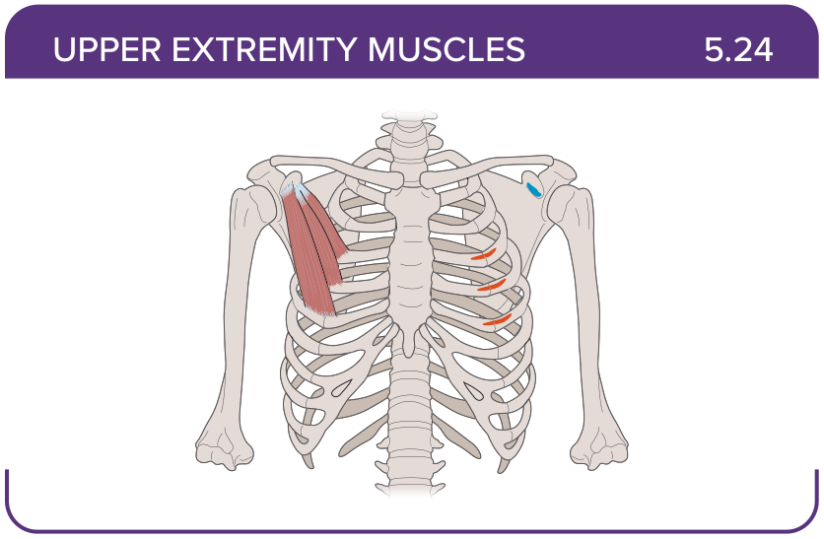
Title: Pectoralis minor
Activity Interaction: select all that apply
Back-of-Card Content:
Proximal insertion:
- *anterior ends of ribs three to five
- anterior surface of the medial half of the clavicle
- sternum and costal cartilages of ribs 1-6
Distal insertion:
- *coracoid process of the scapula
- inferior surface of the middle one third of the clavicle
- medial surface of the humeral shaft

Innervation:
- *medial pectoral nerves
- *lateral pectoral nerves
- subclavian (C5-C6) nerve
- musculocutaneous nerve
Action:
- *protracts and downwardly rotates the shoulder
- protracts and upwardly rotates the shoulder
- retracts and downwardly rotates the shoulder

Card ID: 5.25
Image file: L1344_760136
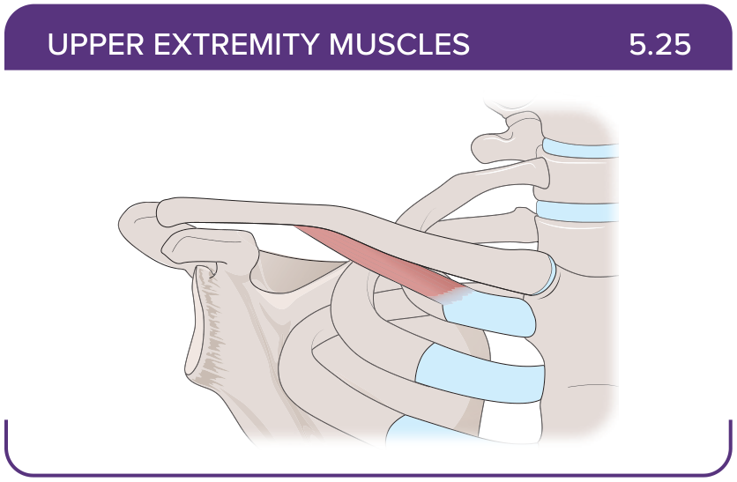
Title: Subclavius
Activity Interaction: select all that apply
Back-of-Card Content:
Proximal insertion:
- *superior surface of the costal end of the first rib
- coracoid process of the scapula
- anterior surface of the manubrium of the sternum
Distal insertion:
- *inferior surface of the middle one third of the clavicle
- coracoid process of the scapula
- posterior surface of the manubrium of the sternum
Innervation:
- medial pectoral nerves
- lateral pectoral nerves
- *subclavian (C5-C6) nerve
- musculocutaneous nerve

Action:
- *stabilizes the clavicle
- downwardly rotates the clavicle

Card ID: 5.26
Image file: L1344_760137
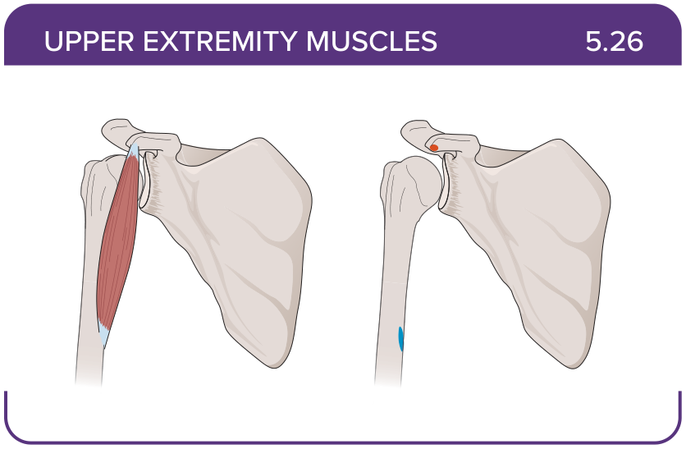
Title: Coracobrachialis
Activity Interaction: select all that apply
Back-of-Card Content:
Proximal insertion:
- *coracoid process of the scapula
- lateral lip of the bicipital groove of the humerus
- lesser tubercle of the humerus
- greater tubercle of the humerus
Distal insertion:
- *medial surface of the humeral shaft
- deltoid tuberosity of the humerus
- intertubercular sulcus of the humerus
- coracoid process of the scapula
Innervation:
- medial pectoral nerves
- lateral pectoral nerves
- subclavian (C5-C6) nerve
- *musculocutaneous nerve
Action:
- *flexes the arm
- *adducts the arm
- abducts the arm
- horizontally adducts the arm

Card ID: 5.27
Image file: L1344_760138
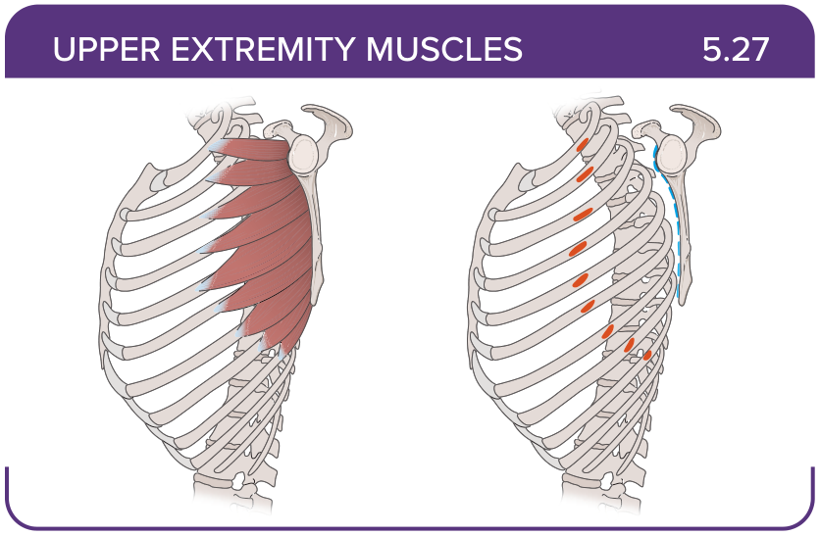
Title: Serratus anterior
Activity Interaction: select all that apply
Back-of-Card Content:
Proximal insertion:
- *external surfaces of ribs one to nine
- external surfaces of ribs six to twelve
- sternum and costal cartilages of ribs 1-6
Distal insertion:
- *medial border of the scapula
- lateral border of the scapula
- coracoid process of the scapula
Innervation:
- *long thoracic (C5-C7) nerve
- subclavian (C5-C6) nerve
- musculocutaneous nerve
- axillary nerve
Action:
- *protracts and upwardly rotates the shoulder
- protracts and downwardly rotates the shoulder
- retracts and upwardly rotates the shoulder
- retracts and downwardly rotates the shoulder

Card ID: 5.28
Image file: L1344_760139
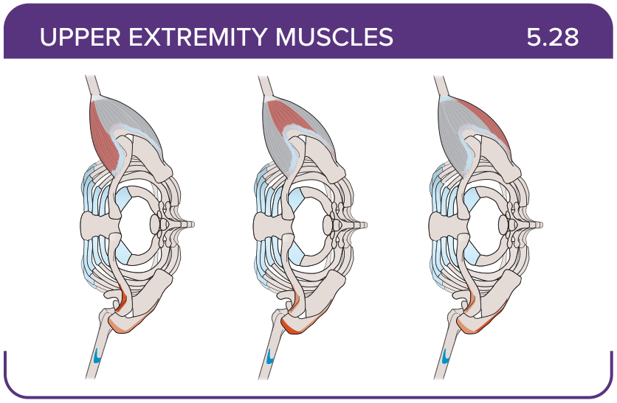
Title: Deltoid
Activity Interaction: select all that apply
Back-of-Card Content:
Proximal insertion:
- *clavicle
- *acromion
- *the spine of the scapula
- coracoid process of the scapula
Distal insertion:
- *deltoid tuberosity of the humerus
- lateral lip of the bicipital groove of the humerus
- medial surface of the humeral shaft
Innervation:
- *axillary nerve
- subclavian (C5-C6) nerve
- musculocutaneous nerve
- long thoracic (C5-C7) nerve

Action:
* flexion and internal rotation of the arm
* abduction of the arm
* extension and external rotation of the arm

Card ID: 5.29
Image file: L1344_760140
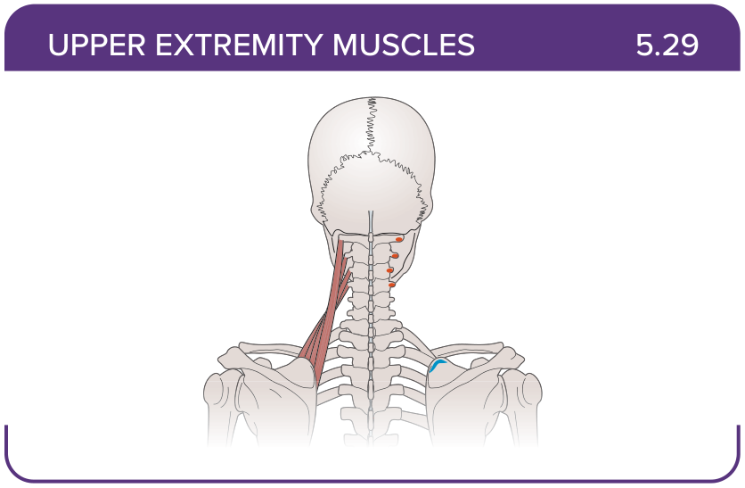
Title: Levator scapulae
Activity Interaction: select all that apply
Back-of-Card Content:
Proximal insertion:
- *transverse processes of C1-C2
- *posterior tubercles of transverse processes C3-C4
- anterior ends of ribs three to five
- superior surface of the costal end of the first rib
Distal insertion:
- *superior angle of the scapula
- *medial border of the scapula superior to the spine of the scapula
- coracoid process of the scapula
- lateral lip of the bicipital groove of the humerus
Innervation:
- *C3-C4
- *dorsal scapular nerve
- long thoracic (C5-C7) nerve
- axillary nerve

Action:
- *elevates and downwardly rotates the scapula
- *extends and side bends the neck
- flexes and side bends the neck
- elevates and upwardly rotates the scapula

Card ID: 5.30
Image file: L1344_760141
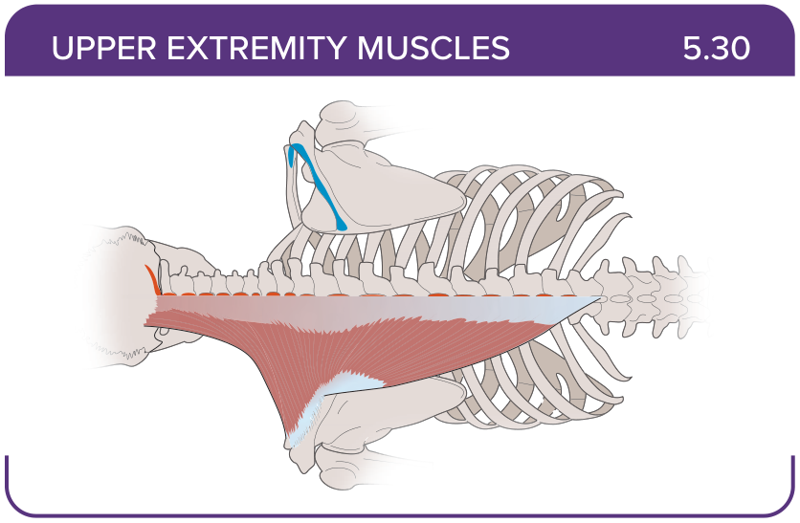
Title: Trapezius
Activity Interaction: select all that apply
Back-of-Card Content:
Proximal insertion:
- *external occipital protuberance and superior nuchal line of the occipital bone, nuchal ligament
- *spinous processes of C7-T12
- *medial border of the acromion process, upper border of the scapular spine
- transverse processes of C7-T12
Distal insertion:
- *posterior aspect of the lateral one third of the clavicle, acromion, and the spine of the scapula
- *medial border of the acromion, upper border of the spine of the scapula
- *triangular space at the base of the scapular spine
- iliac crest
Innervation:
- *accessory nerve
- axillary nerve
- long thoracic (C5-C7) nerve
Action:
- *elevates and upwardly rotates the scapula
- *extends and side bends the neck
- extends and rotates the neck
- *depression, adduction, upward rotation of the scapula

Card ID: 5.31
Image file: L1344_760142
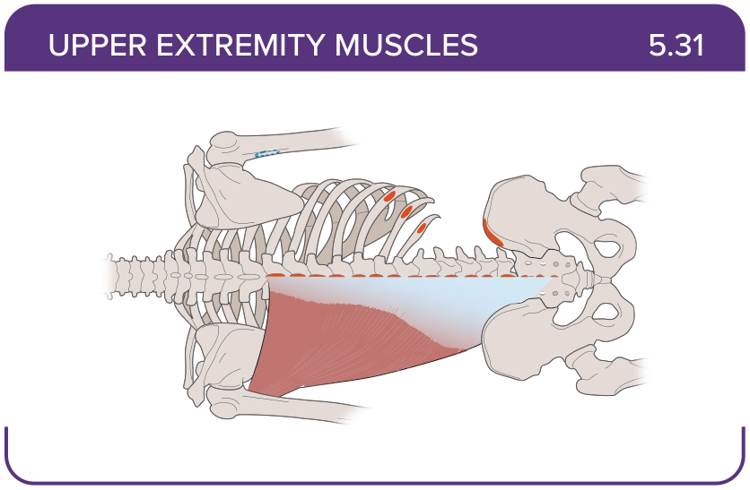
Title: Latissimus dorsi
Activity Interaction: select all that apply
Back-of-Card Content:
Proximal insertion:
- *T7-T12 lumbar vertebrae
- *ribs 9 to 12
- *iliac crest
- upper border of the scapular spine
Distal insertion:
- *intertubercular sulcus of the humerus
- lateral lip of the bicipital groove of the humerus
- coracoid process of the scapula

Innervation:
- *thoracodorsal nerve
- musculocutaneous nerve
- long thoracic (C5-C7) nerve
Action:
- *adducts the arm
- *internal rotation of the shoulder
- externally rotates the shoulder
- protracts and downwardly rotates the shoulder

Card ID: 5.32
Image file: L1344_760143
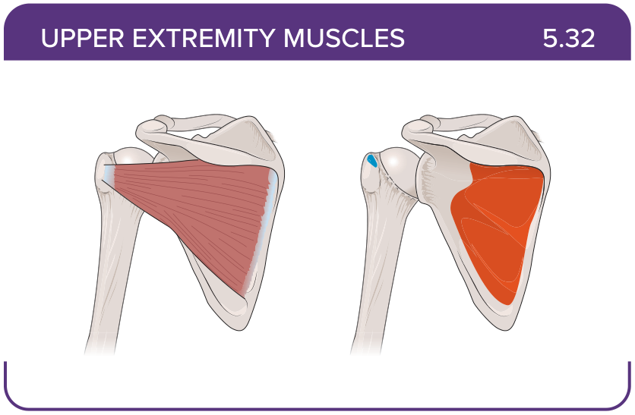
Title: Infraspinatus
Activity Interaction: select all that apply
Back-of-Card Content:
Proximal insertion:
- *infraspinous fossa of the scapula
- lateral border of the dorsal scapular surface
- medial border of the dorsal scapular surface
Distal insertion:
- *greater tubercle of the humerus
- lesser tubercle of the humerus
- intertubercular sulcus of the humerus
Innervation:
- *suprascapular nerve
- subclavian (C5-C6) nerve
- musculocutaneous nerve
- long thoracic (C5-C7) nerve
Action:
- *externally rotates the shoulder
- internally rotates the shoulder
- abducts the arm

Card ID: 5.33
Image file: L1344_760144
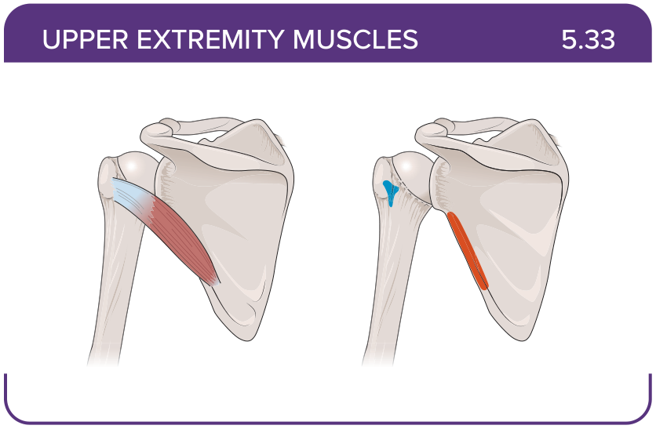
Title: Teres minor
Activity Interaction: select all that apply
Back-of-Card Content:
Proximal insertion:
- *lateral border of the dorsal scapular surface
- subscapular fossa of the scapula
- medial border of the dorsal scapular surface
Distal insertion:
- *greater tubercle of the humerus
- lesser tubercle of the humerus
- coracoid process of the scapula
Innervation:
- *lower and upper subscapular nerve
- musculocutaneous nerve
- suprascapular nerve
Action:
- *externally rotates the shoulder
- internally rotates the shoulder
- abducts the arm

Card ID: 5.34
Image file: L1344_760145
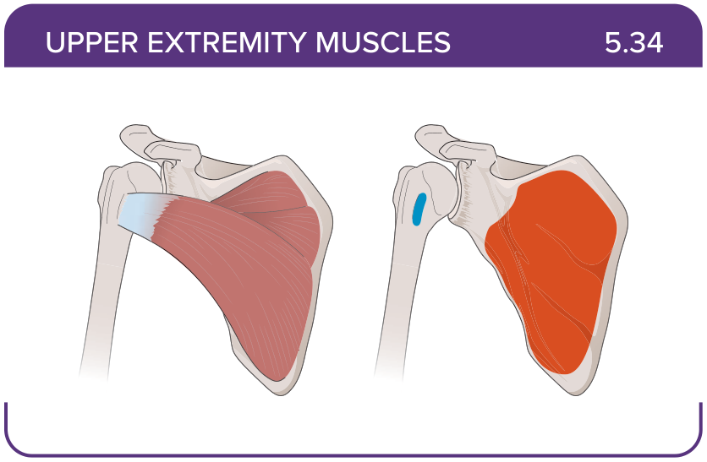
Title: Subscapularis
Activity Interaction: select all that apply
Back-of-Card Content:
Proximal insertion:
- *subscapular fossa of the scapula
- lateral border of the dorsal scapular surface
- medial border of the dorsal scapular surface

Distal insertion:
- *lesser tubercle of the humerus
- greater tubercle of the humerus
- medial surface of the humeral shaft
- intertubercular sulcus of the humerus

Innervation:
- *lower and upper subscapular nerve
- musculocutaneous nerve
- suprascapular nerve
Action:
- *internally rotates the shoulder
- externally rotates the shoulder
- abducts the arm

Card ID: 5.35
Image file: L1344_760146
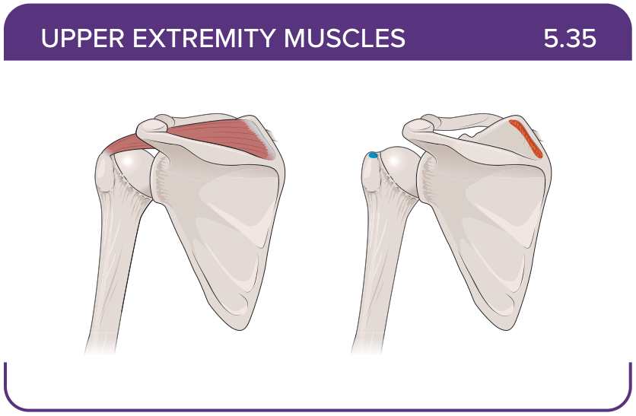
Title: Supraspinatus
Activity Interaction: select all that apply
Back-of-Card Content:
Proximal insertion:
- *supraspinous fossa of the scapula
- medial border of the dorsal scapular surface
- lateral border of the dorsal scapular surface

Distal insertion:
- *greater tubercle of the humerus
- intertubercular sulcus of the humerus
- lesser tubercle of the humerus
Innervation:
- *suprascapular nerve
- lower and upper subscapular nerve
- axillary nerve
Action:
- *abducts the arm
- internally rotates the shoulder
- externally rotates the shoulder

Card ID: 5.36
Image file: L1344_760147
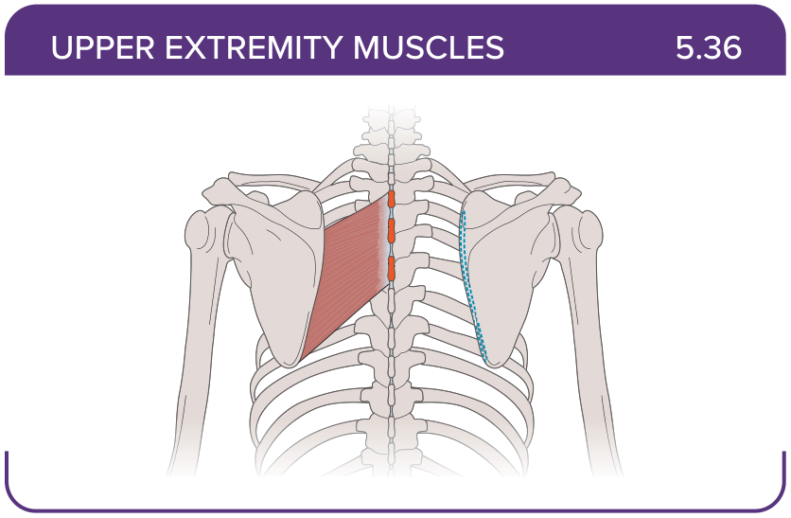
Title: Rhomboid major
Activity Interaction: select all that apply
Back-of-Card Content:
Proximal insertion:
- *spinous processes of T2-T5
- posterior surface of the scapula
- coracoid process
- tubercle above the glenoid cavity

Distal insertion:
- *medial border of the scapula inferior to the spine of the scapula
- intertubercular sulcus of the humerus
- radial tuberosity

Innervation:
- *dorsal scapular nerve
- axillary nerve
- suprascapular nerve
- lower subscapular nerve
Action:
- *retracts and downwardly rotates the scapula
- protracts and downwardly rotates the shoulder
- adducts and internally rotates humerus
- externally rotates the shoulder

Card ID: 5.37
Image file: L1344_760148
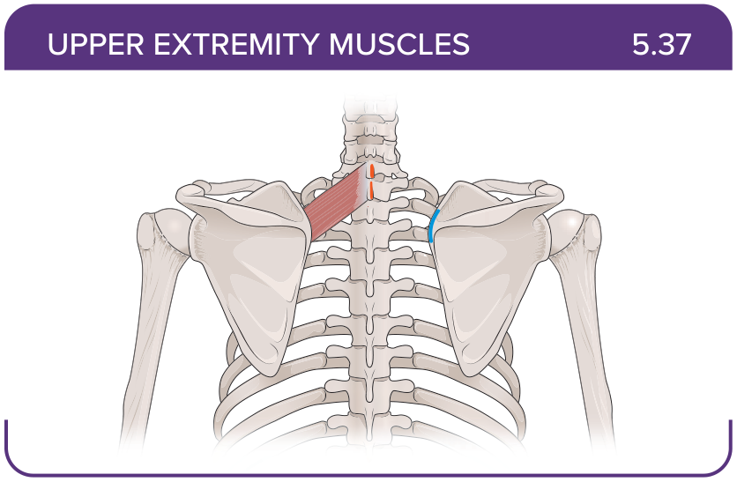
Title: Rhomboid minor
Activity Interaction: select all that apply
Back-of-Card Content:
Proximal insertion:
- *nuchal ligament
- *spinous processes of C7-T1
- coracoid process
- posterior surface of the scapula

Distal insertion:
- *medial border of the scapula adjacent to the spine of the scapula
- intertubercular sulcus of the humerus
- radial tuberosity
- posterior surface of the scapula

Innervation:
- *dorsal scapular nerve
- long thoracic (C5-C7) nerve
- axillary nerve
- suprascapular nerve
Action:
- *retracts and downwardly rotates the scapula
- protracts and downwardly rotates the shoulder
- adducts and internally rotates humerus
- transverse adduction at the glenohumeral joint

Card ID: 5.38
Image file: L1344_760149
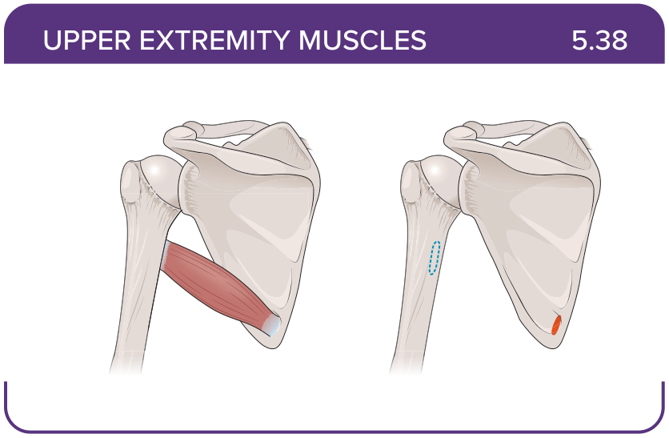
Title: Teres major
Activity Interaction: select all that apply
Back-of-Card Content:
Proximal insertion:
- *posterior surface of the scapula
- coracoid process
- tubercle above the glenoid cavity

Distal insertion:
- *intertubercular sulcus of the humerus
- medial border of the scapula adjacent to the spine of the scapula
- radial tuberosity

Innervation:
- *lower subscapular nerve
- long thoracic (C5-C7) nerve
- axillary nerve
- suprascapular nerve
Action:
- *adducts and internally rotates humerus
- protracts and downwardly rotates the shoulder
- retracts and downwardly rotates the scapula
- externally rotates the shoulder

Card ID: 5.39
Image file: L1344_760150
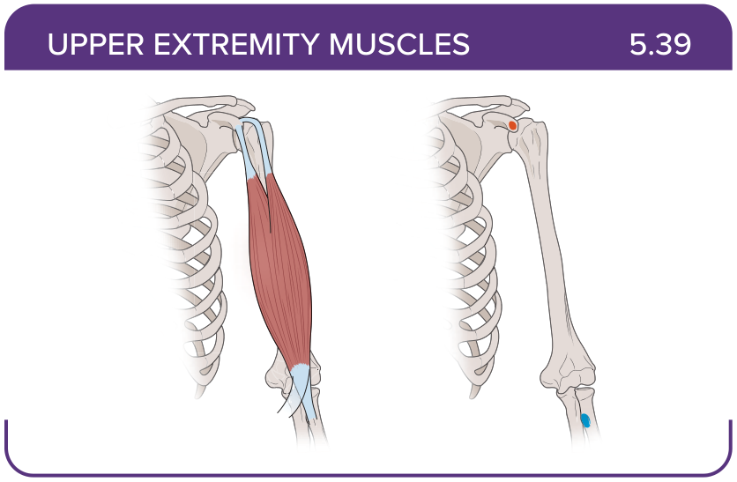
Title: Biceps brachii (long head, short head)
Activity Interaction: select all that apply
Back-of-Card Content:
Proximal insertion:
- *coracoid process
- *tubercle above the glenoid cavity
- posterior shaft of the humerus
Distal insertion:
- *radial tuberosity
- intertubercular sulcus of the humerus
- posterior humeral shaft distal to the radial groove
- lateral epicondyle of the humerus
Innervation:
- *musculocutaneous
- radial
- ulnar
Action:
- *flexes the forearm
- *supinates the forearm
- pronates the forearm
- abducts the arm

Card ID: 5.40
Image file: L1344_760151
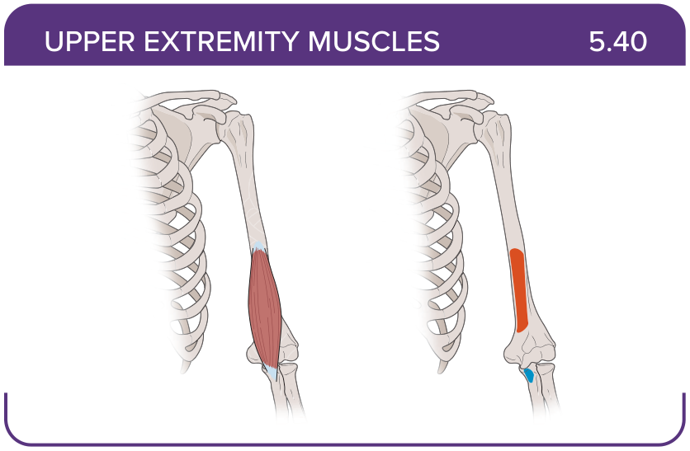
Title: Brachialis
Activity Interaction: select all that apply
Back-of-Card Content:
Proximal insertion:
- *front of the distal humerus
- posterior shaft of the humerus
- coracoid process
- tubercle above the glenoid cavity
Distal insertion:
- *coronoid process
- coracoid process
- radial tuberosity
- lateral radius
Innervation:
- musculocutaneous
- *radial
- ulnar
- axillary nerve

Action:
- *flexes the elbow
- extends the elbow
- pronates the forearm
- supinates the forearm

Card ID: 5.41
Image file: L1344_760152
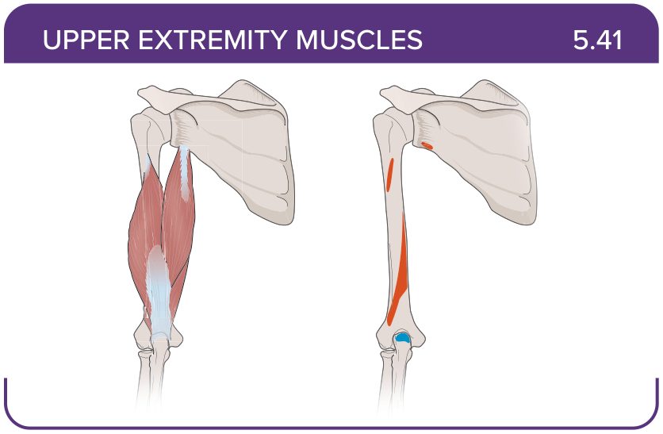
Title: Triceps brachii
Activity Interaction: select all that apply
Back-of-Card Content:
Proximal insertion:
- *infraglenoid tubercle of the scapula
- *posterior shaft of the humerus
- *posterior humeral shaft distal to the radial groove
Distal insertion:
- *olecranon process of the ulna
- coronoid process
- lateral radius
Innervation:
- *radial
- ulnar
- axillary nerve
- musculocutaneous nerve
Action:
- *extends the elbow
- *extends the shoulder
- adducts the arm

Card ID: 5.42
Image file: L1344_760153
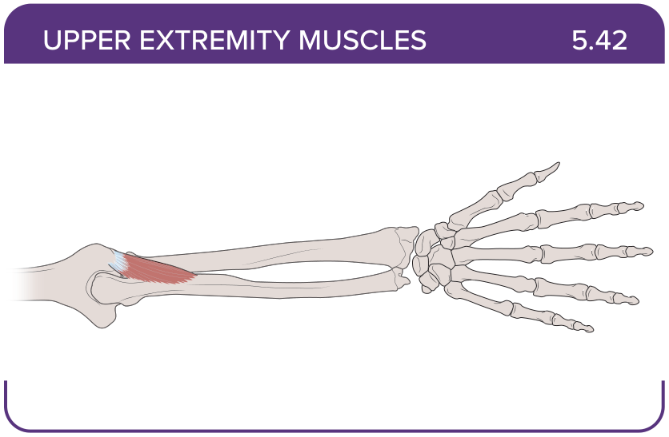
Title: Anconeus
Activity Interaction: select all that apply
Back-of-Card Content:
Proximal insertion:
- *lateral epicondyle of the humerus
- posterior shaft of the humerus
- intertubercular sulcus of the humerus
Distal insertion:
- *lateral aspect of the olecranon process of the ulna
- radial tuberosity
- posterior shaft of the humerus
Innervation:
- *radial nerve
- ulnar
- axillary nerve
- musculocutaneous nerve
Action:
- *extends the elbow
- *extends the shoulder
- pronates the forearm
- supinates the forearm

Card ID: 5.43
Image file: L1344_760154
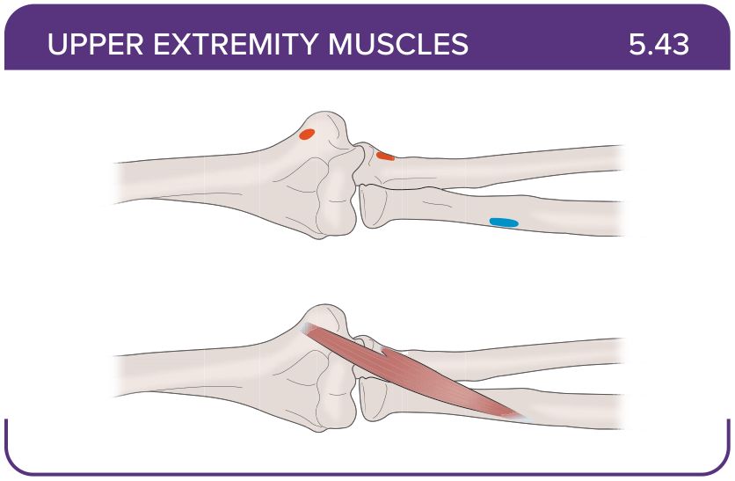
Title: Pronator teres
Activity Interaction: select all that apply
Back-of-Card Content:
Proximal insertion:
- *medial epicondyle of the humerus
- lateral epicondyle of the humerus
- *coronoid process of the ulna
Distal insertion:
- *lateral radius
- radial tuberosity
- olecranon process
- posterior surface of the ulna
Innervation:
- *median nerve
- radial nerve
- musculocutaneous nerve
- ulnar nerve
Action:
- *pronates the forearm
- extends the elbow
- flexes the hand

Card ID: 5.44
Image file: L1344_760155
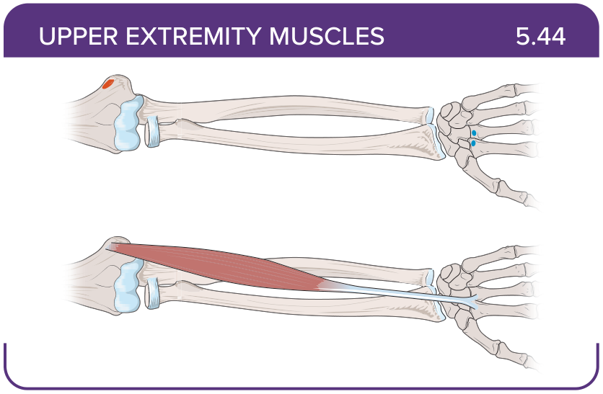
Title: Flexor carpi radialis
Activity Interaction: select all that apply
Back-of-Card Content:
Proximal insertion:
- *medial epicondyle of the humerus
- olecranon process
- posterior surface of the ulna
Distal insertion:
- *base of the second and third metacarpals
- radial tuberosity
- lateral epicondyle of the humerus
Innervation:
- *median nerve
- ulnar nerve
- musculocutaneous nerve
- radial nerve
Action:
- *flexes and abducts the hand
- extends the hand

Card ID: 5.45
Image file: L1344_760156
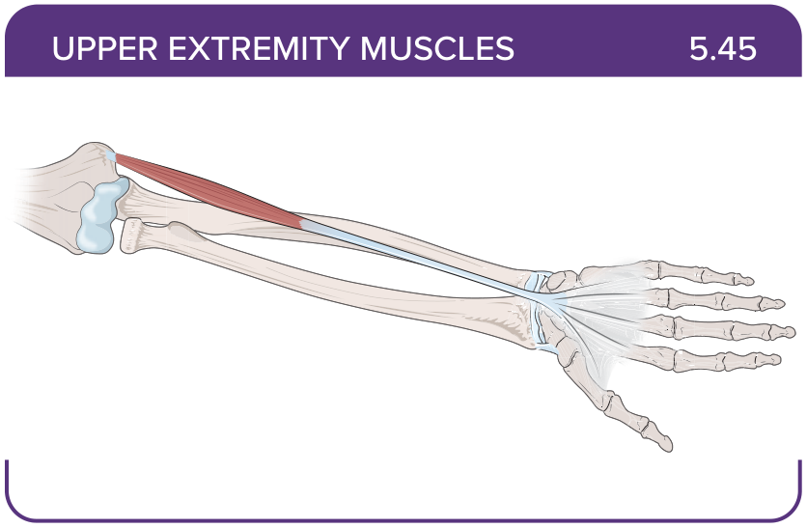
Title: Palmaris longus
Activity Interaction: select all that apply
Back-of-Card Content:
Proximal insertion:
- *medial epicondyle of the humerus
- lateral epicondyle of the humerus
- olecranon process of the ulna
Distal insertion:
- *palmar aponeurosis
- *skin and fascia of the palm
- base of the second and third metacarpals
Innervation:
- *median nerve
- ulnar nerve
- musculocutaneous nerve
- radial nerve
Action:
- *aids in flexion of the wrist and elbow
- *tenses the skin and fascia of the palm
- flexes and adducts the hand

Card ID: 5.46
Image file: L1344_760157
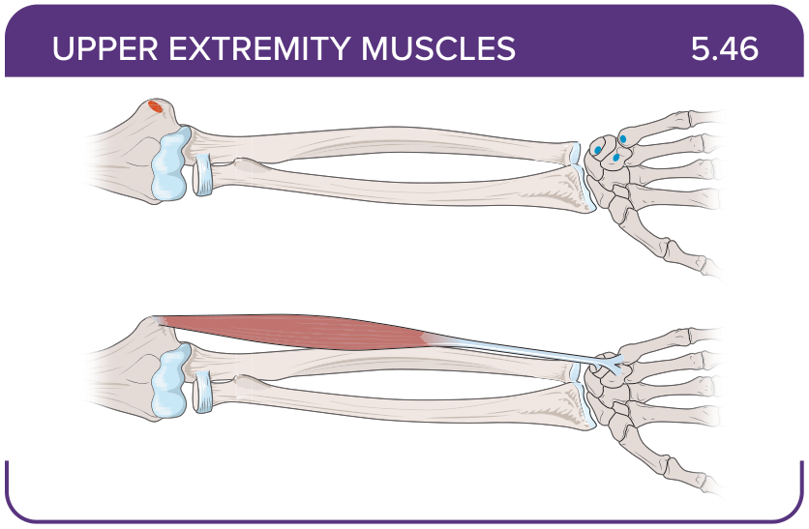
Title: Flexor carpi ulnaris
Activity Interaction: select all that apply
Back-of-Card Content:
Proximal insertion:
- *medial epicondyle of the humerus
- *olecranon process
- *posterior surface of the ulna
Distal insertion:
- *pisiform
- *hamate
- *base of the fifth metacarpal
- lunate
Innervation:
- *ulnar nerve
- musculocutaneous nerve
- radial nerve
- median nerve
Action:
- *flexes and adducts the hand
- tenses the skin and fascia of the palm
- flexes the middle phalanges of fingers two to five

Card ID: 5.47
Image file: L1344_760158
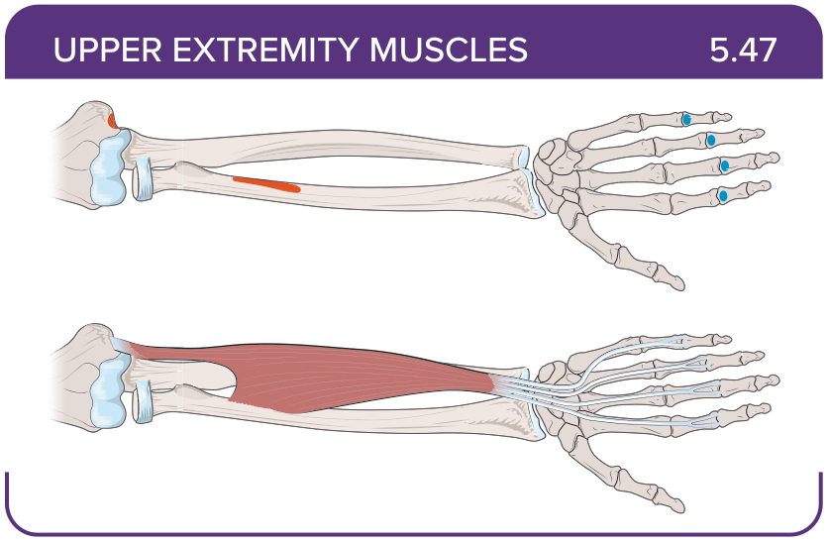
Title: Flexor digitorum superficialis
Activity Interaction: select all that apply
Back-of-Card Content:
Proximal insertion:
- *medial epicondyle of the humerus
- *coronoid process of the ulna
- *the shaft of the radius
- lateral epicondyle of the humerus

Distal insertion:
- *middle phalanges of fingers two to five
- pisiform
- hamate
Innervation:
- *median nerve
- ulnar nerve
- musculocutaneous nerve
- radial nerve
Action:
- *flexes the wrist
- *flexes the middle phalanges of fingers two to five
- flexes distal interphalangeal joints

Card ID: 5.48
Image file: L1344_760159
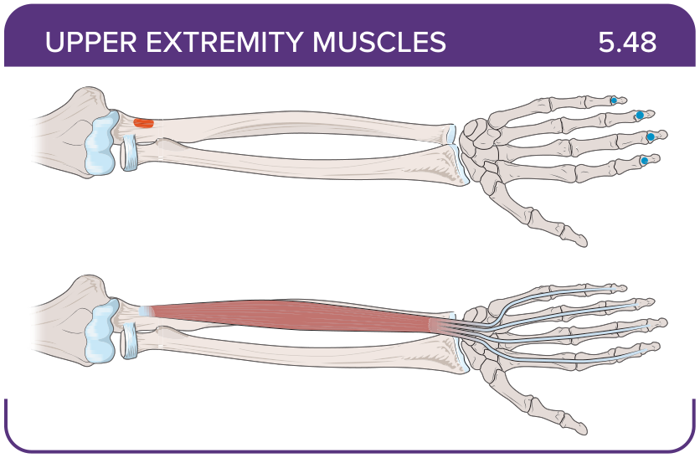
Title: Flexor digitorum profundus
Activity Interaction: select all that apply
Back-of-Card Content:
Proximal insertion:
- *coronoid process
- *anteromedial surface of the ulna
- *interosseous membrane
- medial epicondyle of the humerus

Distal insertion:
- *distal phalanges of fingers two to five
- base of the second and third metacarpals
- middle phalanges of fingers two to five
Innervation:
- median nerve (fingers 2 and 3)
- *ulnar nerve (fingers 4 and 5)
- musculocutaneous nerve
- radial nerve
Action:
- *flexes distal interphalangeal joints
- flexes proximal interphalangeal joints
- flexes the wrist

Card ID: 5.49
Image file: L1344_760160
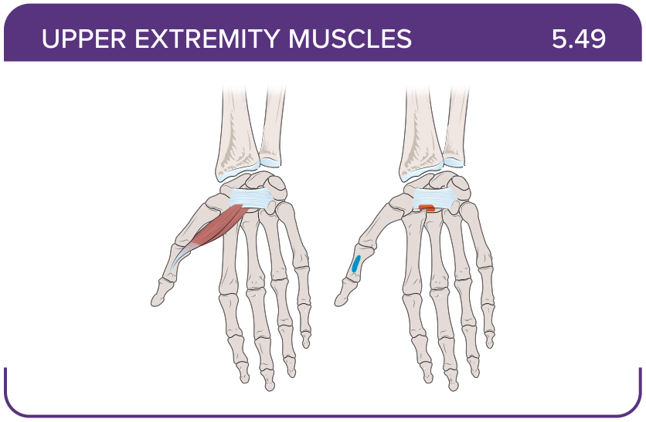
Title: Flexor pollicis longus
Activity Interaction: select all that apply
Back-of-Card Content:
Proximal insertion:
- *anterior surface of the radius
- *interosseous membrane
- anteromedial surface of the ulna
Distal insertion:
- *distal phalanx of the thumb
- proximal phalanx of the thumb
- base of the second and third metacarpals

Innervation:
- *median nerve
- ulnar nerve
- musculocutaneous nerve
- radial nerve

Action:
- *flexes the distal phalanx of the thumb
- flexes the proximal phalanx of the thumb
- abducts and extends the thumb

Card ID: 5.50
Image file: L1344_760161
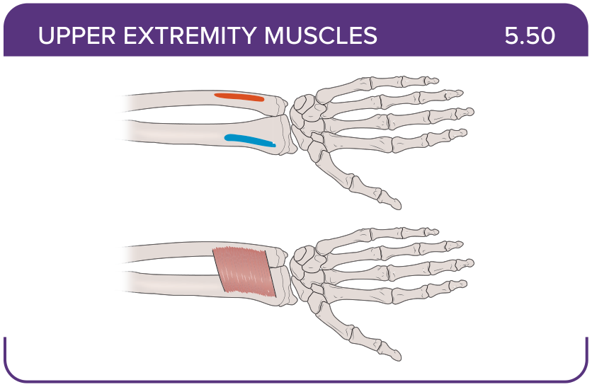
Title: Pronator quadratus
Activity Interaction: select all that apply
Back-of-Card Content:
Proximal insertion:
- *distal portion of the anterior ulnar shaft
- Proximal anteromedial surface of the ulna
- posterior shaft of the radius
Distal insertion:
- *distal surface of the anterior radius
- interosseous membrane
- base of the distal phalanx of the thumb
Innervation:
- *median nerve
- ulnar nerve
- musculocutaneous nerve
- radial nerve
Action:
- *pronates the forearm
- flexes the wrist
- extends the wrist
- stabilizes the distal radioulnar joint

Card ID: 5.51
Image file: L1344_760162
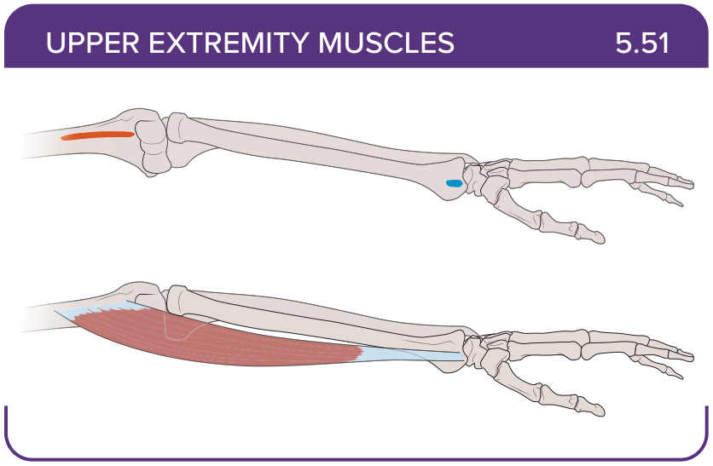
Title: Brachioradialis
Activity Interaction: select all that apply
Back-of-Card Content:
Proximal insertion:
- *lateral supracondylar ridge at the distal end of the humerus
- anteromedial surface of the ulna
- posterior shaft of the humerus
Distal insertion:
- *base of the styloid process of the radius
- base of the second and third metacarpals
- base of the distal phalanx of the thumb
- pisiform
Innervation:
- median nerve
- ulnar nerve
- musculocutaneous nerve
- *radial nerve
Action:
- *flexes the forearm
- flexes the shoulder
- pronates the forearm

Card ID: 5.52
Image file: L1344_760163
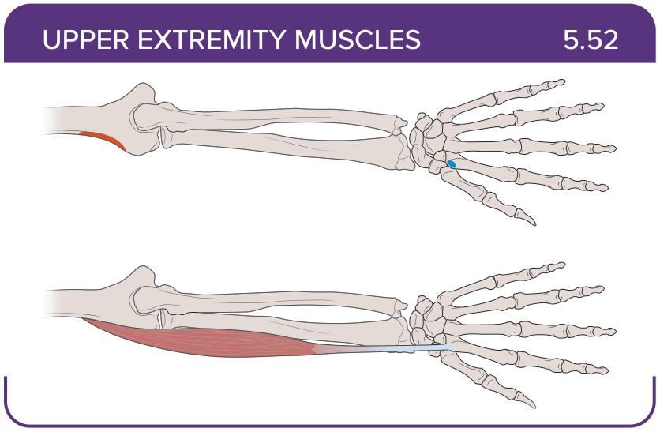
Title: Extensor carpi radialis longus
Activity Interaction: select all that apply
Back-of-Card Content:
Proximal insertion:
- *lateral supracondylar ridge of the humerus
- dorsal shaft of the radius
- lateral epicondyle of the humerus
- medial epicondyle of the humerus

Distal insertion:
- *base of the second metacarpal
- middle phalanges of fingers two to five
- hamate
- base of the distal phalanx of the thumb

Innervation:
- median nerve
- ulnar nerve
- musculocutaneous nerve
- *radial nerve

Action:
- *extends and abducts the hand
- extends the thumb
- extends distal interphalangeal joints

Card ID: 5.53
Image file: L1344_760164
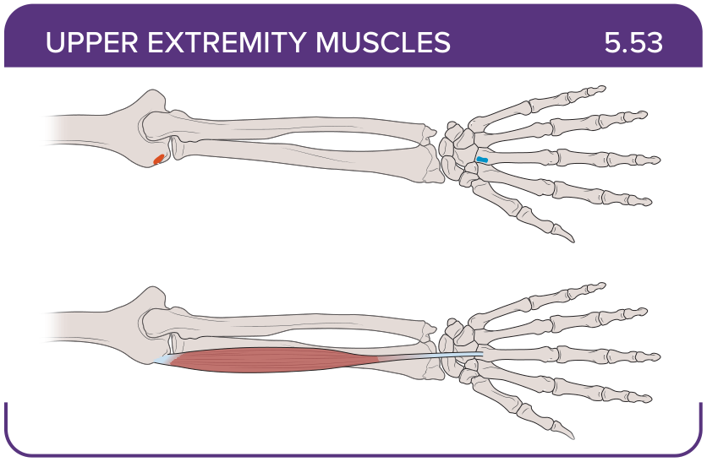
Title: Extensor carpi radialis brevis
Activity Interaction: select all that apply
Back-of-Card Content:
Proximal insertion:
- *lateral epicondyle of the humerus
- medial epicondyle of the humerus
- olecranon process
Distal insertion:
- *base of the third metacarpal
- interosseous membrane
- base of the second and third metacarpals
Innervation:
- *posterior interosseous nerve (radial)
- musculocutaneous nerve
- radial nerve
- median nerve
Action:
- *extends and abducts the hand
- extends and adducts the hand
- extends the thumb
- extends distal interphalangeal joints

Card ID: 5.54
Image file: L1344_760165
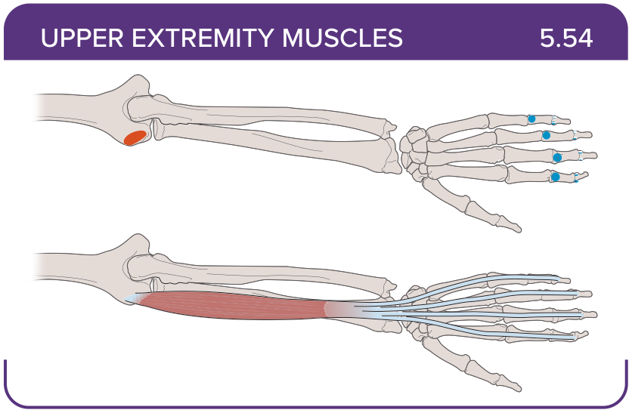
Title: Extensor digitorum
Activity Interaction: select all that apply
Back-of-Card Content:
Proximal insertion:
- *lateral epicondyle of the humerus
- *proximal ulna
- olecranon process
- medial epicondyle of the humerus
Distal insertion:
- *extensor expansions
- *distal phalanges of the fingers
- interosseous membrane
- proximal phalanges of the fingers
Innervation:
- *posterior interosseous nerve (radial)
- radial nerve
- median nerve
Action:
- *extends the hand and abducts the fingers
- extends and adducts the hand
- extends the thumb
- extends distal interphalangeal joints

Card ID: 5.55
Image file: L1344_760166
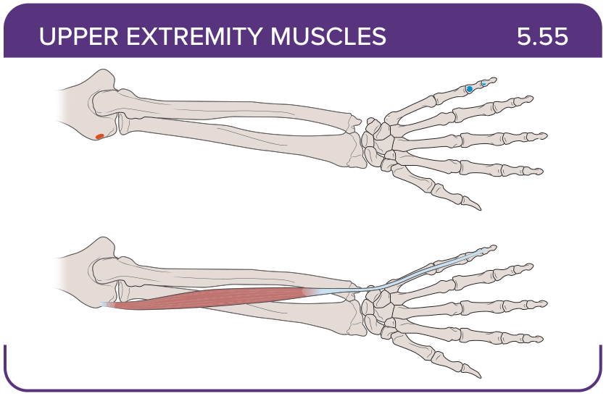
Title: Extensor digiti minimi
Activity Interaction: select all that apply
Back-of-Card Content:
Proximal insertion:
- *lateral epicondyle of the humerus
- medial epicondyle of the humerus
- dorsal shaft of the radius and ulna
- interosseous membrane

Distal insertion:
- *extensor expansion
- *distal phalanx of finger five
- pisiform
Innervation:
- *posterior interosseous nerve (radial)
- ulnar nerve
- median nerve
Action:
- *extends the little finger
- adducts the wrist
- extends the thumb

Card ID: 5.56
Image file: L1344_760167
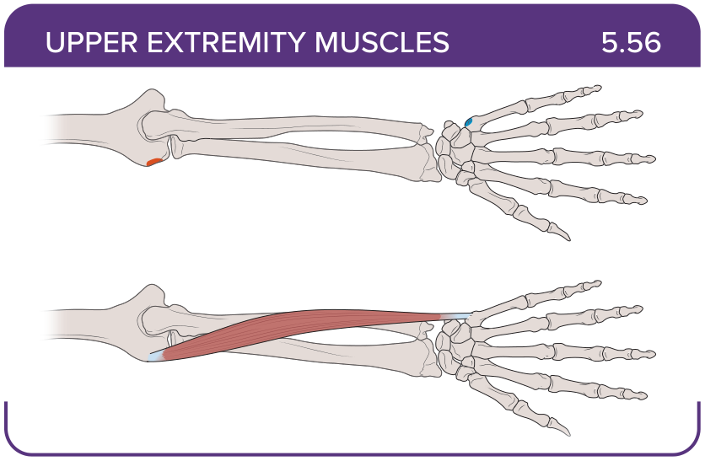
Title: Extensor carpi ulnaris
Activity Interaction: select all that apply
Back-of-Card Content:
Proximal insertion:
- *lateral epicondyle of the humerus
- *posterior border of the ulna
- anteromedial surface of the ulna
- posterior shaft of the humerus
Distal insertion:
- *base of the fifth metacarpal
- base of the second and third metacarpals
- middle phalanges of fingers two to five
- base of the distal phalanx of the thumb
Innervation:
- *posterior interosseous nerve (radial)
- ulnar nerve
- median nerve
Action:
- *extends and adducts the hand
- extends the thumb
- extends the little finger

Card ID: 5.57
Image file: L1344_760168
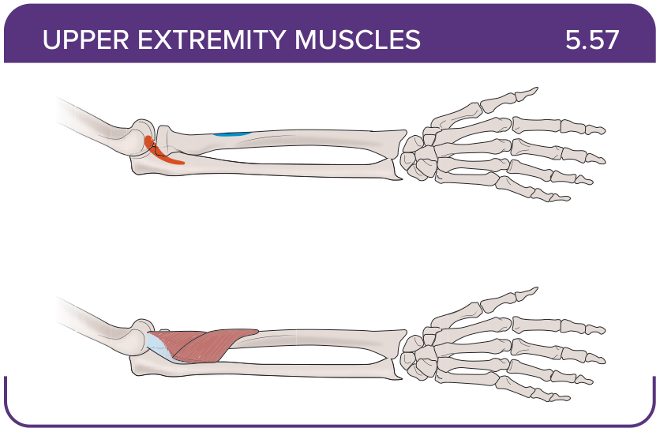
Title: Supinator
Activity Interaction: select all that apply
Back-of-Card Content:
Proximal insertion:
- lateral epicondyle of the humerus
- *proximal ulna
- medial epicondyle of the humerus
- interosseous membrane
Distal insertion:
- *proximal end of the radius
- interosseous membrane
- anteromedial surface of the ulna
- posterior shaft of the humerus
Innervation:
- *posterior interosseous nerve (radial)
- ulnar nerve
- musculocutaneous nerve
- radial nerve
Action:
- *supinates the forearm
- flexes the elbow
- extends the elbow

Card ID: 5.58
Image file: L1344_760169
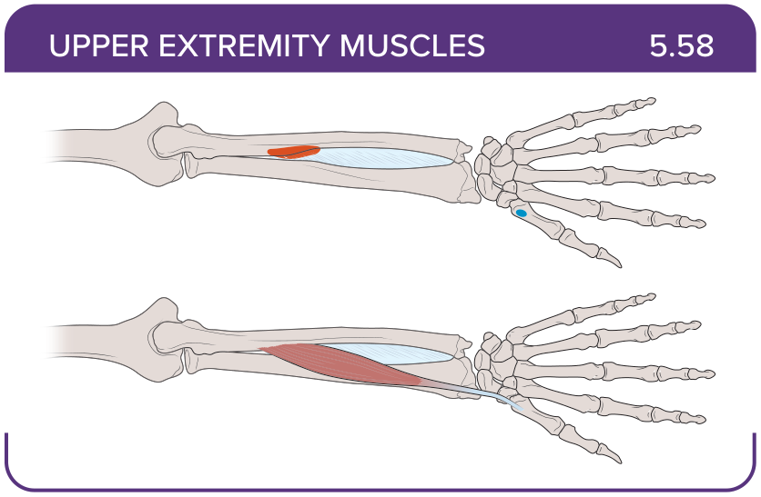
Title: Abductor pollicis longus
Activity Interaction: select all that apply
Back-of-Card Content:
Proximal insertion:
- *posterior surface of the radius and ulna
- *interosseous membrane
- dorsal shaft of the radius and ulna
- lateral epicondyle of the humerus
Distal insertion:
- *base of the first metacarpal
- *trapezium
- base of the distal phalanx of the thumb
- hamate
Innervation:
- *posterior interosseous nerve (radial)
- ulnar nerve
- musculocutaneous nerve
- radial nerve
Action:
- *abducts the thumb
- *extends the thumb
- adducts the thumb
- flexes the thumb

Card ID: 5.59
Image file: L1344_760170
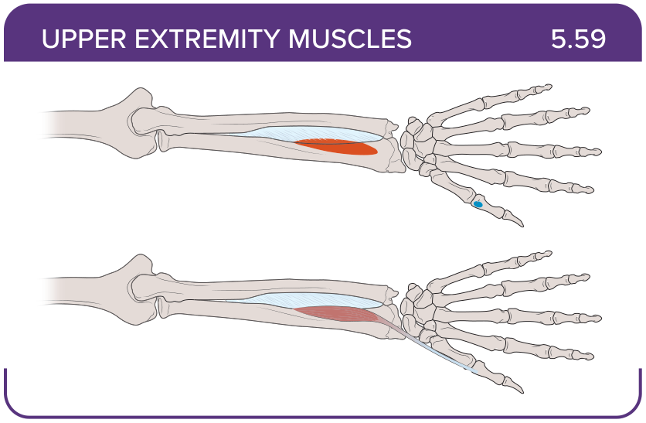
Title: Extensor pollicis brevis
Activity Interaction: select all that apply
Back-of-Card Content:
Proximal insertion:
- *dorsal shaft of the radius and ulna
- *interosseous membrane
- lateral epicondyle of the humerus
- medial epicondyle of the humerus

Distal insertion:
- *base of the proximal phalanx of the thumb
- base of the distal phalanx of the thumb
- base of the second and third metacarpals

Innervation:
- *posterior interosseous nerve (radial)
- ulnar nerve
- musculocutaneous nerve
- radial nerve
Action:
- *extends the thumb
- adducts the thumb
- flexes the thumb

Card ID: 5.60
Image file: L1344_760171
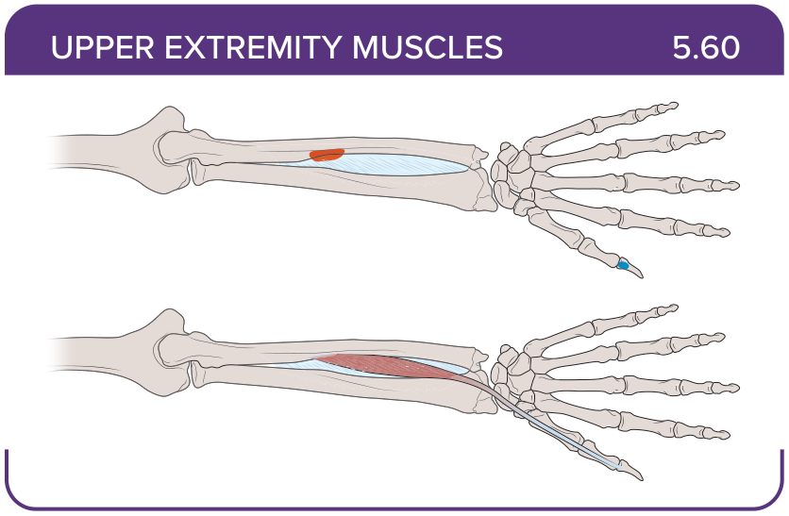
Title: Extensor pollicis longus
Activity Interaction: select all that apply
Back-of-Card Content:
Proximal insertion:
- *dorsal shaft of the radius and ulna
- *interosseous membrane
- lateral epicondyle of the humerus
- medial epicondyle of the humerus
Distal insertion:
- *base of the proximal phalanx of the thumb
- base of the distal phalanx of the thumb
- base of the second and third metacarpals
Innervation:
- *posterior interosseous nerve (radial)
- ulnar nerve
- musculocutaneous nerve
- radial nerve
Action:
- *extends the thumb
- adducts the thumb
- flexes the thumb

Card ID: 5.61
Image file: L1344_760172
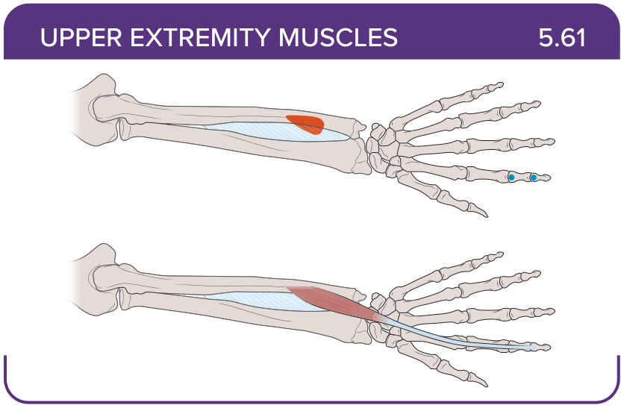
Title: Extensor indicis
Activity Interaction: select all that apply
Back-of-Card Content:
Proximal insertion:
- dorsal shaft of the radius and ulna
- *interosseous membrane
- *posterior surface of the distal ulna
- lateral epicondyle of the humerus
Distal insertion:
- *tendon of the extensor digitorum of the index finger
- base of the second and third metacarpals
- middle phalanges of fingers two to five

Innervation:
- *posterior interosseous nerve (radial)
- ulnar nerve
- musculocutaneous nerve
- radial nerve
Action:
- *extends the index finger
- *aids in extending the wrist
- flexes distal interphalangeal joints

Card ID: 5.62
Image file: L1344_760173
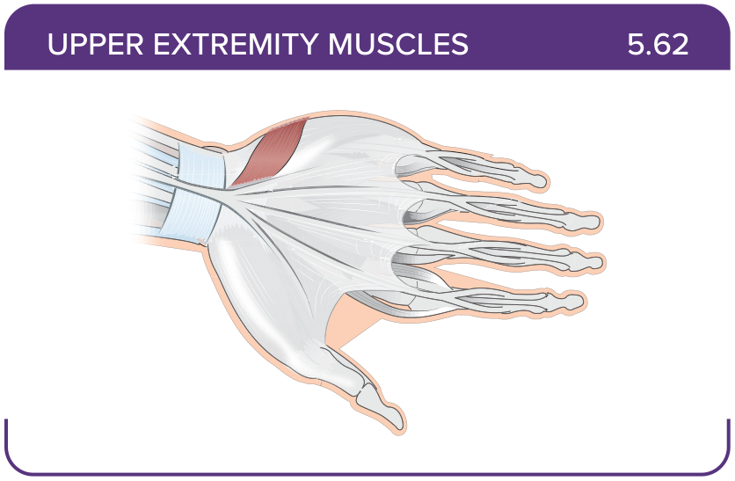
Title: Palmaris brevis
Activity Interaction: select all that apply
Back-of-Card Content:
Proximal insertion:
- *palmar aponeurosis
- *flexor retinaculum of the hand
- interosseous membrane
- dorsal shaft of the ulna

Distal insertion:
- *skin along the medial margin of the hand
- interosseous membrane
- base of the third and fourth metacarpals

Innervation:
- posterior interosseous nerve (radial)
- ulnar nerve
- radial nerve
- * ulnar (C8-T1) nerve
Action:
- *wrinkles the skin on the hypothenar eminence
- *deepens the hollow of the hand
- *assists with grip
- flexes the wrist

Card ID: 5.63
Image file: L1344_760174
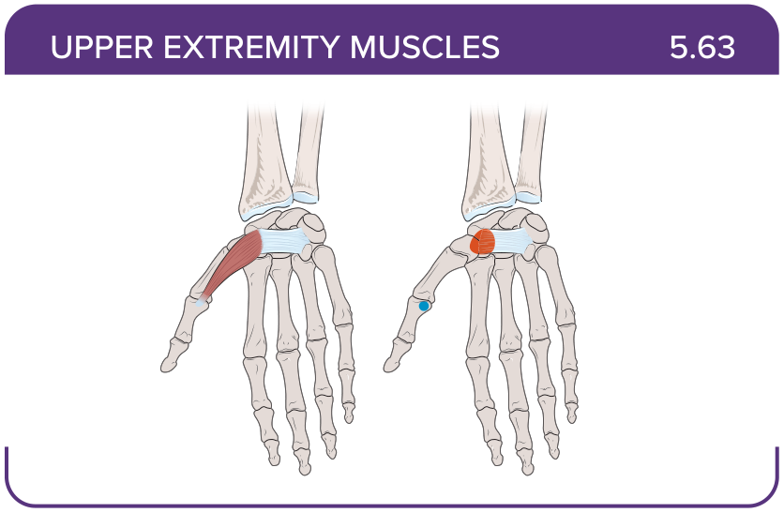
Title: Abductor pollicis brevis
Activity Interaction: select all that apply
Back-of-Card Content:
Proximal insertion:
- *tubercles of the scaphoid and trapezium bones
- *flexor retinaculum of the hand
- skin along the medial margin of the hand
Distal insertion:
- *lateral aspect of the base of the proximal phalanx of the thumb
- base of the second and third metacarpals
- middle phalanges of fingers two to five
Innervation:
- posterior interosseous nerve (radial)
- ulnar nerve
- ulnar (C8-T1) nerve
- *median (C8-T1) nerve
Action:
- *abducts the thumb at the carpometacarpal joint
- extends the thumb
- flexes the thumb

Card ID: 5.64
Image file: L1344_760175
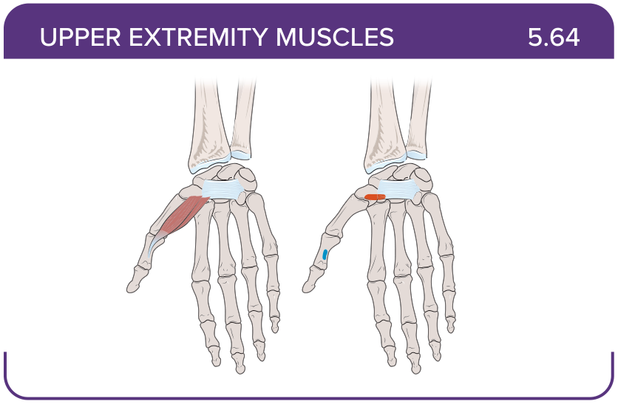
Title: Flexor pollicis brevis
Activity Interaction: select all that apply
Back-of-Card Content:
Proximal insertion:
- *tubercle of the trapezium bone
- *palmar aspects of the capitate and trapezoid bones
- *flexor retinaculum of the hand
Distal insertion:
- *lateral aspect of the base of the proximal phalanx of the thumb
- base of the distal phalanx of the thumb
- lateral aspect of the distal phalanx of the thumb
Innervation:
- *median nerve
- *ulnar nerve
- radial nerve
- posterior interosseous nerve (radial)
Action:
- *flexes the thumb
- flexes the wrist
- flexes the middle phalanges

Card ID: 5.65
Image file: L1344_760176
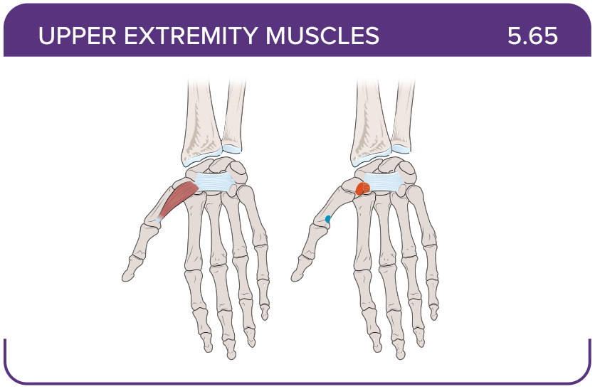
Title: Opponens pollicis
Activity Interaction: select all that apply
Back-of-Card Content:
Proximal insertion:
- *tubercle of the trapezium bone
- *the flexor retinaculum of the hand
- scaphoid
- lunate
Distal insertion:
- *anterolateral aspect of the body of the first metacarpal
- base of the distal phalanx of the thumb
- medial aspect of the distal phalanx of the thumb
Innervation:
- posterior interosseous nerve (radial)
- radial nerve
- ulnar (C8-T1) nerve
- *median nerve
Action:
- *opposes the thumb towards other fingers
- extends the thumb
- flexes the thumb

Card ID: 5.66
Image file: L1344_760177
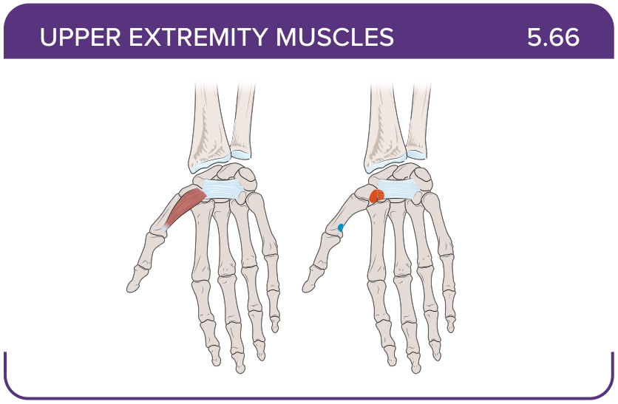
Title: Abductor digiti minimi
Activity Interaction: select all that apply
Back-of-Card Content:
Proximal insertion:
- *pisiform bone
- *tendon of the flexor carpi ulnaris
- hamate
Distal insertion:
- *medial aspect of the base of the proximal phalanx of the fifth finger
- distal phalanx of the fifth finger
- volar side of the distal phalanx of the fifth finger
Innervation:
- *ulnar (C8-T1) nerve
- posterior interosseous nerve (radial)
- radial nerve
Action:
- *abducts the little finger at the metacarpophalangeal (MCP) joint
- flexes the little finger
- assists in wrist extension

Card ID: 5.67
Image file: L1344_760178
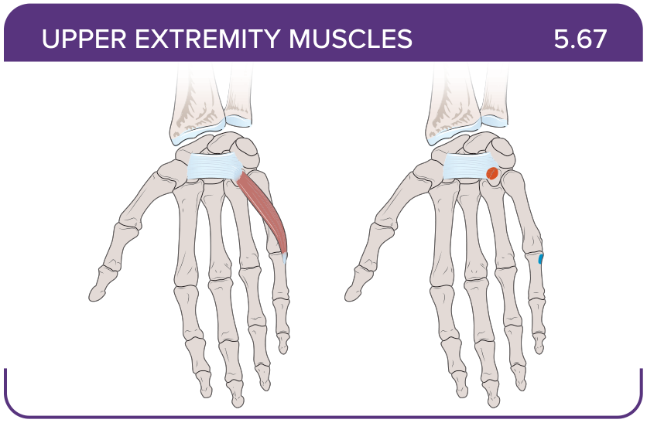
Title: Flexor digiti minimi
Activity Interaction: select all that apply
Back-of-Card Content:
Proximal insertion:
- *hook of the hamate
- *flexor retinaculum of the hand
- palmar aponeurosis
- capitate
Distal insertion:
- *medial aspect of the base of the proximal phalanx of the fifth finger
- distal phalanx of the fifth finger
- volar side of the distal phalanx of the fifth finger
Innervation:
- *ulnar (C8-T1) nerve
- posterior interosseous nerve (radial)
- radial nerve
Action:
- *flexes the fifth finger at the metacarpophalangeal (MCP) joint
- abducts the little finger at the metacarpophalangeal (MCP) joint
- flexes the little finger
- assists in wrist extension

Card ID: 5.68
Image file: L1344_760179
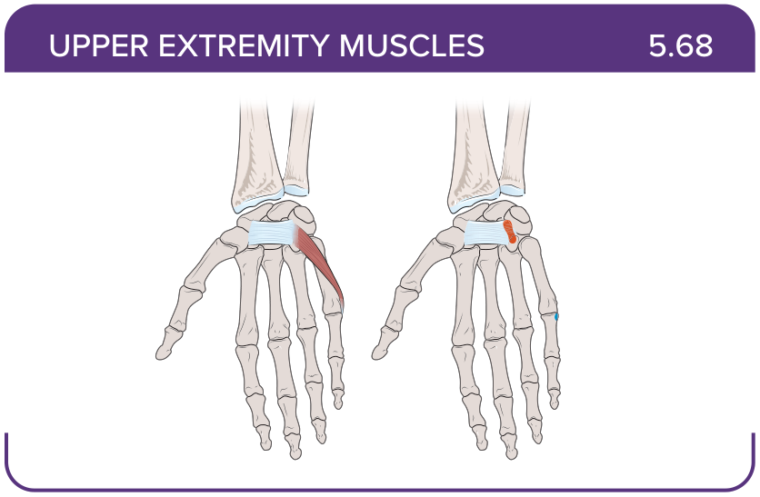
Title: Opponens digiti minimi
Activity Interaction: select all that apply

Back-of-Card Content:
Proximal insertion:
- *hook of the hamate
- *flexor retinaculum of the hand
- palmar aponeurosis
- capitate
Distal insertion:
- *medial aspect of the fifth metacarpal
- distal phalanx of the fifth finger
- volar side of the distal phalanx of the fifth finger
Innervation:
- *ulnar (C8-T1) nerve
- posterior interosseous nerve (radial)
- radial nerve
Action:
- *opposes the fifth finger toward the thumb
- flexes the fifth finger
- assists in wrist extension

Card ID: 5.69
Image file: L1344_760180
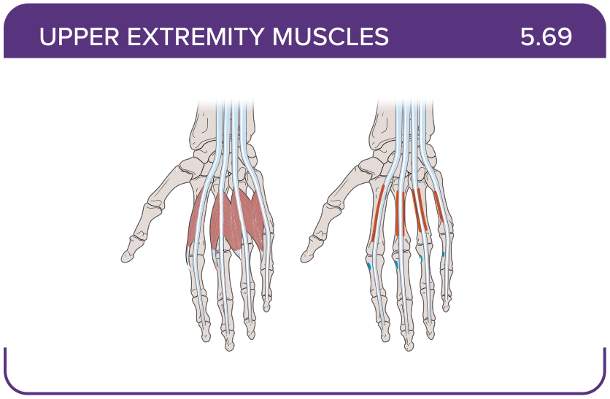
Title: Lumbricals (one to four)
Activity Interaction: select all that apply
Back-of-Card Content:
Proximal insertion:
- *tendon of the flexor digitorum profundus
- interosseous membrane
- base of the second, third, and fourth metacarpals
Distal insertion:
- *radial aspect of the extensor hood of each digit
- distal phalanx of the second, third, and fourth phalanges
- palmar aponeurosis
Innervation:
- *median nerve (fingers 2 and 3)
- *ulnar nerve (fingers 4 and 5)
- radial nerve
- posterior interosseous nerve (radial)
Action:
- *flexion at the metacarpophalangeal (MCP) joint
- *extension at the interphalangeal (IP) joint
- extension at the metacarpophalangeal (MCP) joint
- flexion at the interphalangeal (IP) joint

Card ID: 5.70
Image file: L1344_760181
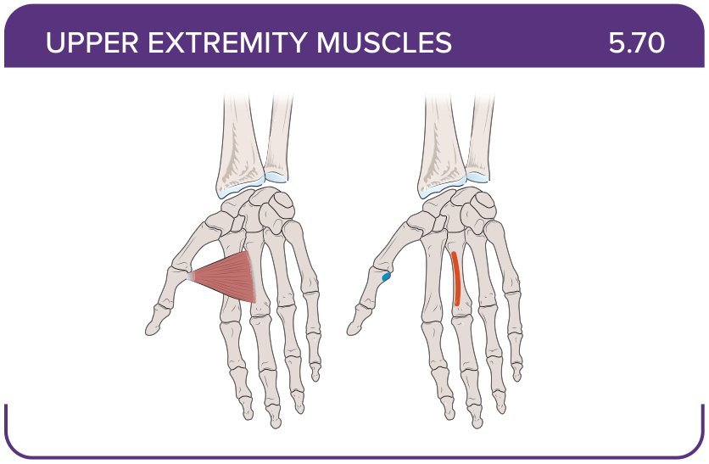
Title: Adductor pollicis transversus
Activity Interaction: select all that apply
Back-of-Card Content:
Proximal insertion:
- *palmar aspect of the body of the third metacarpal
- tubercle of the trapezium bone
- interosseous membrane
- lunate
Distal insertion:
- *medial aspect of the base of the proximal phalanx of the thumb
- base of the distal phalanx of the thumb
- lateral aspect of the base of the proximal phalanx of the thumb
Innervation:
- *ulnar (C8-T1) nerve
- posterior interosseous nerve (radial)
- radial nerve
Action:
- *thumb adduction at the carpometacarpal joint
- extends the thumb
- opposes the thumb toward the fifth finger

Card ID: 5.71
Image file: L1344_760182
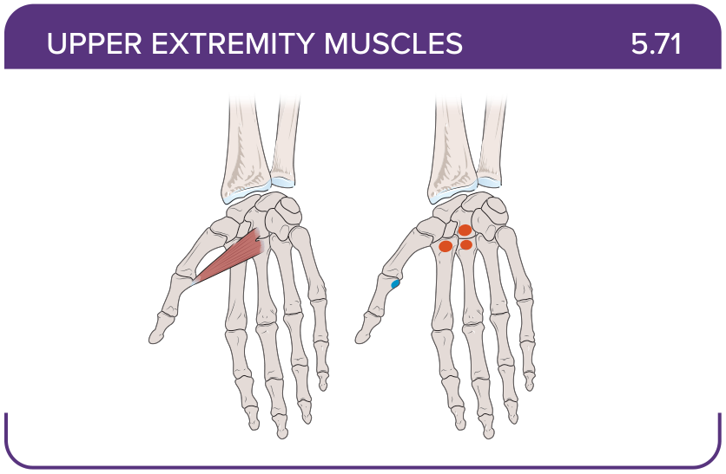
Title: Adductor pollicis oblique
Activity Interaction: select all that apply
Back-of-Card Content:
Proximal insertion:
- *palmar aspects of the capitate bone
- *bases of the second and third metacarpal bones
- tubercle of the trapezium bone
Distal insertion:
- *medial aspect of the base of the proximal phalanx of the thumb
- base of the distal phalanx of the thumb
- lateral aspect of the base of the proximal phalanx of the thumb
Innervation:
- *ulnar (C8-T1) nerve
- posterior interosseous nerve (radial)
- radial nerve
Action:
- *thumb adduction at the carpometacarpal joint
- extends the thumb
- opposes the thumb toward the fifth finger

Card ID: 5.72
Image file: L1344_760183
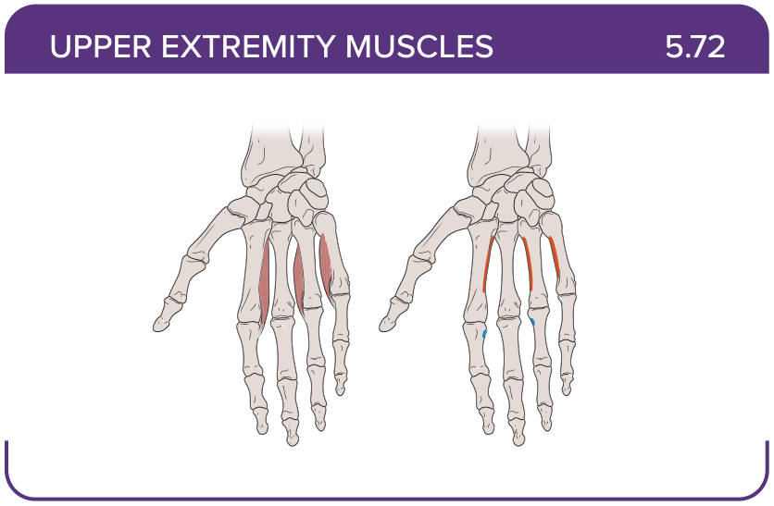
Title: Palmar interossei (one to three)
Activity Interaction: select all that apply
Back-of-Card Content:
Proximal insertion:
- *palmar surface of the second, fourth, and fifth metacarpal bones
- tendon of the flexor digitorum profundus
- interosseous membrane
- base of the first, second, and third metacarpals
Distal insertion:
- *extensor hood and base of the proximal phalanges of their related digits
- radial aspect of the extensor hood of each digit
- distal phalanx of the second, third, and fourth phalanges
- palmar aponeurosis
Innervation:
- *ulnar (C8-T1) nerve
- median nerve
- posterior interosseous nerve (radial)
Action:
- *adduction of the thumb, index, ring, and little fingers
- *contribute to flexion of the metacarpophalangeal (MCP) and extension of the interphalangeal (IP) joint
- abduction of the thumb, index, ring, and little fingers
- flexes distal interphalangeal joints

Card ID: 5.73
Image file: L1344_760184
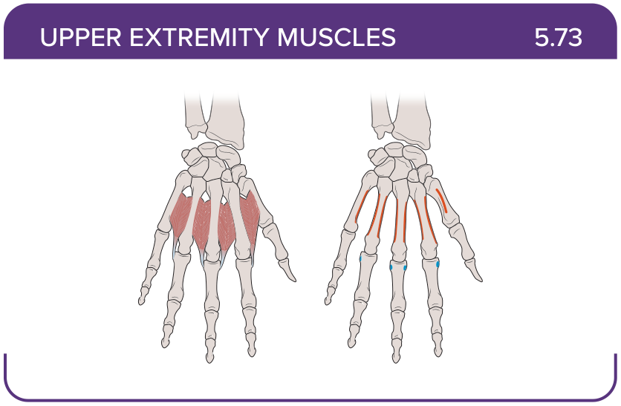
Title: Dorsal interossei (one to four)
Activity Interaction: select all that apply
Back-of-Card Content:
Proximal insertion:
- *radial side of the lateral metacarpal
- *ulnar side of the medial metacarpal
- palmar aponeurosis
Distal insertion:
- *radial side of the lateral metacarpal and extensor expansion
- distal phalanx of the second, third, and fourth phalanges
- distal phalanx of the thumb
Innervation:
- *ulnar (C8-T1) nerve
- posterior interosseous nerve (radial)
- radial nerve
Action:
- *abducts the finger
- *simultaneously flexes the metacarpophalangeal (MCP) joint and extends the interphalangeal (IP) joint
- extension at the metacarpophalangeal (MCP) joint
- flexion at the interphalangeal (IP) joint

